https://www.aau.edu.jo/en/academics/faculty-arts-and-sciences/department-basic-sciences-and-humanities

Date: 09/21/2022
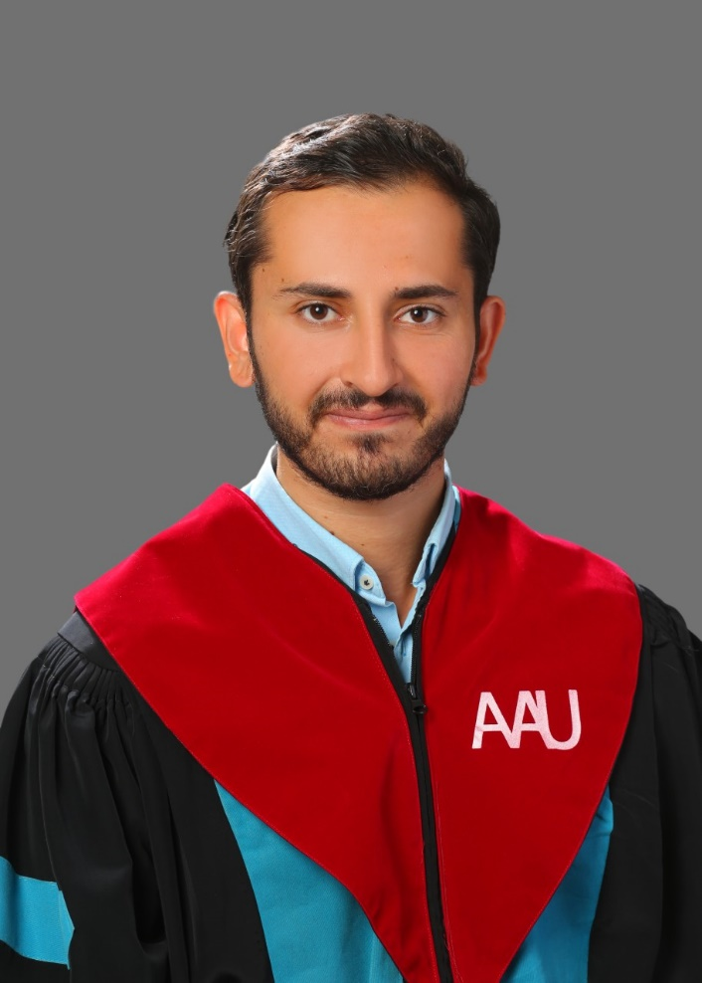

Tariq Mohammed Ali Farghal

Personal information
Title: Faculty member
Academic Rank: Lecturer
Date & Place of Birth: 05/12/1995. Irbid, Jordan
Nationality: Jordanian
Address:
(1)- Aydun, Irbid, Jordan
(2) Um al-Summaq, Khalda, Amman
Phone No.: 0795834977

Academic qualifications
Degree | Major | Duration  (From-To) |  | University |  |  | Country
Master’s | Linguistics | 2018-2020 |  | Michigan State University |  |  | USA
Bachelor’s | English Language & Literature | 2014-2017 |  | Yarmouk University |  |  | Jordan
Business English Diploma | Business English | 2013-2014 |  | London Meridian College |  |  | London, UK
High School Diploma | Scientific Stream | 2013 |  | High Model School |  |  | Jordan
Teaching experience
Duration | Rank |  | Institution |  | Department/Faculty | Country
2021-2022  1 year | Secondary and High School English Teacher |  | International Independent School |  | English Department | Jordan
2020-2021  1 year | Teaching Assistant |  | Michigan State University |  | Linguistics Department | Jordan
2017-2018  1 year | English Language Support Teacher |  | Al-Mada International School |  | English Department | Jordan
2017-2018  1 year | Language Tutor  (part-time) |  | Maysoon Al-Asfar Institute |  | Languages and Humanities Department | Jordan
6 months | Secondary and High School English Teacher |  | Al-Qabas National School |  | English Department | Jordan
2014  6 months | Arabic Teacher for Non-Native Speakers  (part-time) |  | Kuwait Campus |  | N/A | Kuwait

Other experience
Duration | Rank | Institution | Department/Faculty | Country
2019 - 2021  2 years | Business Translator & Transcriptionist  (part-time) | Michigan State University, | Department of Writing, Rhetoric, and American Cultures | USA  (in person & online)
2021  6 months | Legal & Political Translator  (part-time project-based position) | Michigan State University | Department of Political Science | USA (online)
2019-2020 | Research Assistant in Arabic Learning for Non-Native Speakers  (full-time) | Michigan State University, | Arabic Department | USA
6 months | Operational Manager, English Teacher, & Arabic Teacher for foreigners | Excellence Academy | Administration & Languages Department | Jordan

Publications
Journals
Author/s  (In Order) | Title |  | Journal | Vol./No. | Publication Date
Tariq Farghal | Hyperraising in Jordanian Arabic |  | ProQuest | 28261406 | 2020
Conferences
Author/s  (In Order) | Title | Conference |  | Country |  | Date
University of Granada | The 14th Conference of AIDA | AIDA |  | Spain |  | June 6-9, 2021

Books
Author/s  (In Order) | Title | Publisher | Edition | Date
Dr. Hasan Ahmad al-Hyari | Book Translation of The Salvation Path and the Sacred Prophetic Meaning | Amazon Kindle | First  Edition | 2022

Memberships OF Scientific and professional societies
university Committees

Workshops Attended
General & Business English Course in London Meridian College in London, UK
ACTFL Workshop for teaching English for foreigner at the University of Michigan in Anna Arbor, Michigan
University Systems and Instructions Course
The use of modern technologies in teaching Course
Preparation of the course file
Publishing in Refereed International Journals
Academic Supervision on University Theses and the Role of the Academic Supervisor Course
International Accreditation and Academic Rankings Course
Jordanian Accreditation for Academic Programs Course
Community Partnerships and Sustainable Development Course
Learning Outcomes, Exam Preparation and Assessment Tools Course
Office Services for Private Jordanian Universities Course
Course design and preparation of courses depending on the type of learning
International Project Application Course

Workshops Offered

Research interests
I am highly interested in theoretical linguistics, especially syntax syntax-semantic interference, and phonology. I have special interest in Arabic linguistics and its syntactic complexities, particularly the linguistic units of dialects and vernacular.
As I have worked as a translator, I have also developed keen interest in translation theories, and as a teacher, I have also interest in teaching methodologies, discourse analysis, and applied linguistics.

Languages
Arabic (Native)
English (Fluent & Professional)

Other Community activities
Awards received
- Received Scholarship Award in Graduate Studies by Michigan State University
- Received Fellowship Award in Arabic-English Translation
- Honored Student Award in the English Department at Yarmouk University

References
- Name: Sadam Issa,
Position: Faculty Member of the Department of Linguistics, Languages, and Cultures at Michigan State University
Email: sissa@msu.edu

- Name: Steven Fraiberg
Position: Faculty Member of the Department of Writing, Rhetoric, and American Cultures at Michigan State University
Email: sfraibe2@gmail.com

- Name: Camelia Suleiman
Position: Faculty Member of the Department of Linguistics, Languages, and Cultures at Michigan State University
Email: csuleima@msu.edu

- Name: Ayman Mohamed
Position: Faculty Member of the Department of Linguistics, Languages, and Cultures at Michigan State University
Email: mohame44@msu.edu

- Name: Alan Munn
Position: Faculty Member of the Department of Linguistics, Languages, and Cultures at Michigan State University
Email: amunn@msu.edu

