Research First page

Psychometric Properties of the Attitudes Scale towards Electronic Tests among Graduate Students
Abstract: The current study aimed at identifying the Psychometric Properties of attitudes scale towards electronic tests among graduate students, the researchers briefly explained various electronic test types used to asses students’ achievement. The study's significance lied in providing a valid and reliable scale, as well as demonstrating the appropriateness of electronic tests whether they meet the aims of distance education or not. Thus, universities can develop the tests' quality and improve them. The sample of the study consisted of (690) students (male and female) of the Amman Arab University. A scale of (56) items was built for the study. Different procedures were done to assure the validity of the scale such as Exploratory factor analysis, construct validity, and discriminatory validity, as for the reliability Cronbach's Alpha, Split Half, Standard Error of Estimate, and Hoyt equation were used. All these indications showed appropriate and reasonable results for the scale. The arithmetic means and standard deviations of students' attitudes towards electronic tests were calculated. The statistical results showed that the attitude scale has acceptable psychometric properties, as students had positive ones. It also showed statistical differences in students' attitudes attributed to gender in favor of female students due to their personal circumstances. However, there were no statistical differences found attributed to faculty or to the interaction between faculty and gender. The general results of this scale could encourage other researchers to implement it on various universities in different countries and to integrate technology with traditional teaching in their coming courses.
Keywords: Psychometric Properties, Attitudes towards Electronic Tests, Assessment
Mo'en Salman Alnasraween, Nusaiba Ali Almousa, Jehad Ali Almomani, Raeda Mofid Ammari , "Psychometric Properties of the Attitudes Scale towards Electronic Tests among Graduate Students," Universal Journal of Educational Research, Vol. 8, No. 12B, pp. 8262-8273, 2020. DOI: 10.13189/ujer.2020.082631.

Faculty of Arts and Science Members at Amman Arab University and their
Perspective of Distance learning Reality in light of COVID-19
Dr. Raeda Mofid Ammari¹
Dr. Leena Ali Mahmmod Aljarrah²
Areej Jamil Khalifeh³
raedaammari@aau.edu.jo¹ , linaaljarrah@aau.edu.jo^{2,} arrejkhalifeh@aau.edu.jo³
Faculty of Arts and Science, Amman Arab University, Amman, Jordan

Abstract
The current study aims at revealing the reality of Distance learning and its impact on the process of education during Coronavirus spread, from the faculty members' point of view at Amman Arab University. To achieve the objectives of this study, the researchers followed descriptive approaches. The study sample reached (138) faculty members at AAU. The participants were selected by the comprehensive enumeration method. A questionnaire of (34) items was developed and distributed to collect the required data, whose reliability coefficient was (0.79). After conducting the statistical analysis using the (SPSS) program, the findings reveal that the level of Distance learning during COVID-19 in AAU from the faculty members' perspective is moderate, and the advantages of Distance learning during COVID-19 are moderate. However, the disadvantages of Distance learning results are high. The findings also indicate that there are no statistically significant differences at the level of significance (α ≤0.05) in the responses of the participants according to gender, academic qualification, academic rank, faculty, and years of experience variables. Due to the findings, the researchers recommend holding training courses in the field of Distance learning for both, teachers and students, to help eliminate all obstacles that prevent benefiting from the Distance learning system.

Keywords: COVID-19, Amman Arab University, Distance learning, faculty members

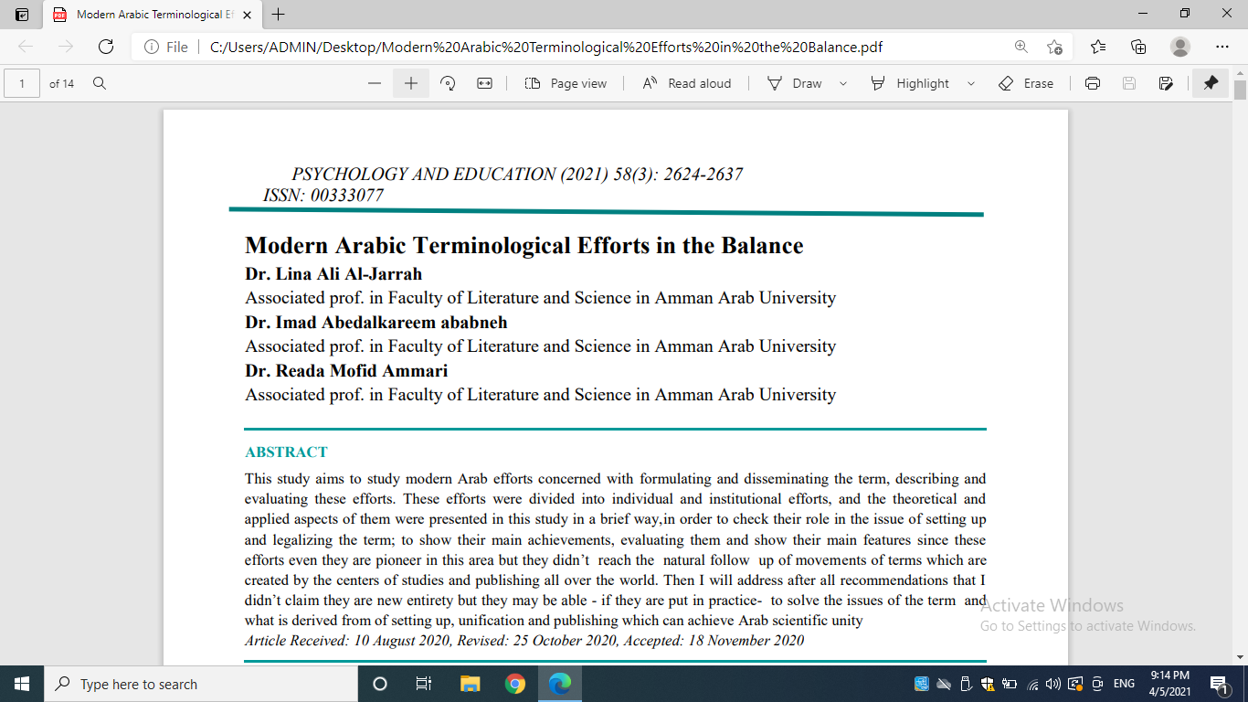

Constructing a Scale of Students’ Attitudes Towards Distance Learning at
Jordanian Private Universities

Abstract: The purpose of this study was to construct and apply a measuring scale to investigate students’ attitudes towards distance learning at Amman Arab University; a private university in Jordan, through the evaluation of students’ attitudes, opinions, and perceptions of distance learning. The study sample consisted of 731 students. A scale was developed, consisting of 45 items. The validity and reliability of the scale were assured; using the Factor Analysis procedure the results showed a one factor present in the performance on this scale, also the scree plot assured this result. In addition, the result showed a moderately positive attitude towards distance learning; teacher and student interaction were encouraging, also the results showed no statistically significant difference between the arithmetic means attributed to student gender. Thus, students’ attitudes and opinions favored distant learning.
Keywords: Constructing a scale, student attitudes, distance learning
Mo’en Salman Alnasraween, Raeda Mofid Ammari, Sharif Abdelrhman Alsoudi, Taha Oklah Alkursheh & Yazan Shaker Almahameed, Constructing a Scale of Students’ Attitudes Towards Distance Learning at Jordanian Private Universities, International Journal of Humanities, Arts and Social Sciences 7(1) 2021 https://dx.doi.org/10.20469/ijhss.7.20001-1

Students’ Attitudes towards Applying Cooperative Learning Strategy
at Amman Arab University

Areej J. Khalifeh
Faculty of Arts and Science, Amman Arab University, Amman, Jordan
Arrejkhalifeh@aau.edu.jo

Dr. Nusaiba A. Almousa
Faculty of Education and Psychology, Amman Arab University, Amman, Jordan
nusaiba@aau.edu.jo

Dr. Raeda M. Ammari
Faculty of Arts and Science, Amman Arab University, Amman, Jordan
Raedaammari@aau.edu.jo

Dr. Lina A. Jarrah
Faculty of Arts and Science, Amman Arab University, Amman, Jordan
linaaljarrah@aau.edu.jo

Acknowledgement
First and foremost, praises and thanks to God, the Almighty, for His abundance of blessings throughout my research work to complete it successfully.
I want to express my deep and sincere gratitude to my father; may his soul rest in peace since he was my model in writing research, sincerity and motivation have deeply inspired me to achieve the best. I am very much thankful to my family for their love, understanding, prayers, and continuous support to me. Also, many thanks to Professor Odeh Abu Sunineh for being the teacher and advisor. Finally, many thanks to the doctors who did their best to finish this study with me.

Abstract
The current research aimed at discussing the use of the Cooperative Learning strategy and its applications in AAU English courses. The researchers collected the data from several online resources and books. A questionnaire was developed as another assessment tool and was distributed to Amman Arab University students. The sample was 600 students from all faculties. In addition to conducting interviews with English Doctors at Amman Arab University to inquire about their teaching strategies and methods and the extent to which they apply them. The findings of the interviews were very positive. In consensus, they preferred face-to-face instruction as well as various cooperative strategies. Moreover, the results of the questionnaires showed that students’ attitudes towards Cooperative Learning were high, as the means reached (3.810) with a standard deviation of (0.507). Furthermore, students aged twenty years and over displayed more interest and involvement concerning the Cooperative Learning strategies than others. Regarding the gender variable, it was in favor of the females. Some recommendations were suggested to be implemented in teaching English.

Keywords: Teaching strategy, Cooperative Learning, students, University

A Corpus-Based Study of English Synonyms:
Small, Little, Tiny and Petite
Dr. Raeda Mofid Ammari
Amman Arab University
Dr. Wajed Rasmi Al Ahmad
Ministry of Education
Abstract:
Synonymy is one of the complex linguistic features that learners of English face as a second language. This study aims at investigating the similarities and differences that exist among the four English synonyms, i.e., small, little, tiny, and petite concerning their genres, comparison, grammatical patterns and collocations. The data is driven from (COCA) as a native corpus and (CLC) as the non-native. The results of both corpora show that small and little are frequently used while petite is rarely used in COCA but not used at all in CLC. Besides, little is mainly used in TV and fiction genres whereas small, tiny, and petite are used in news and magazine genres. The grammatical patterns are similar except for one pattern with little in COCA. Further, outcomes unveiled that there is no comparison form for petite in both corpora whereas; little has two comparison forms with a difference in meaning.

Keywords: synonyms, corpus, grammatical patterns, collocations, learner corpus

The Use of Passive Voice in News Reports for Political Purposes
Yazan Shaker Almahameed
Department of English Language and Translation, Amman Arab University
Email: yazan.shaker@yahoo.com
Khaleel Bader Al Bataineh
Department of English Language and Translation, Amman Arab University
Email: khaleelb@u.edu.jo ; khaleelbader@gmail.com
Raeda Mofid George Ammari
Department of Basic Sciences and Humanities, Amman Arab University
raedaammari@aau.edu.jo

Abstract
This study aims primarily at identifying the purposes of using passive construction in political news reports. The study also examines how the use of passive voice affects the attitudes of readers towards political issues. The use of passive voice can lead to ambiguity, affecting the clarity of meaning by hiding the identity of the doer of the action. However, being vague about the doer of the action is mostly deliberate in political news to serve special purposes. To collect data, the researchers refer to three newspapers: namely The Washington Post, The Wall Street Journal, and The Guardian. Some articles discussing political issues were carefully chosen from those newspapers. The analysis of the results reveals that the passive voice is used in the selected political news reports to fulfill four main purposes; first, when the journalist aims at placing emphasis on the action rather than the doer of the action, he/she omits by phrase, replacing it with marginal information. Second, when the subject of the sentence is the core of the discussion, the journalist ends the passive sentence with a by phrase. Third, passive construction is used when the writer of political news avoids assigning responsibility to anybody. Fourth, the passive is used in political reports with modal auxiliaries when the writer wants to express his/her opinion clearly about what is possible, necessary, or prohibited. The analysis of results also reveals that the use of passive voice can contribute actively to changing the attitudes and views of the recipients

