Date 22/11/2020

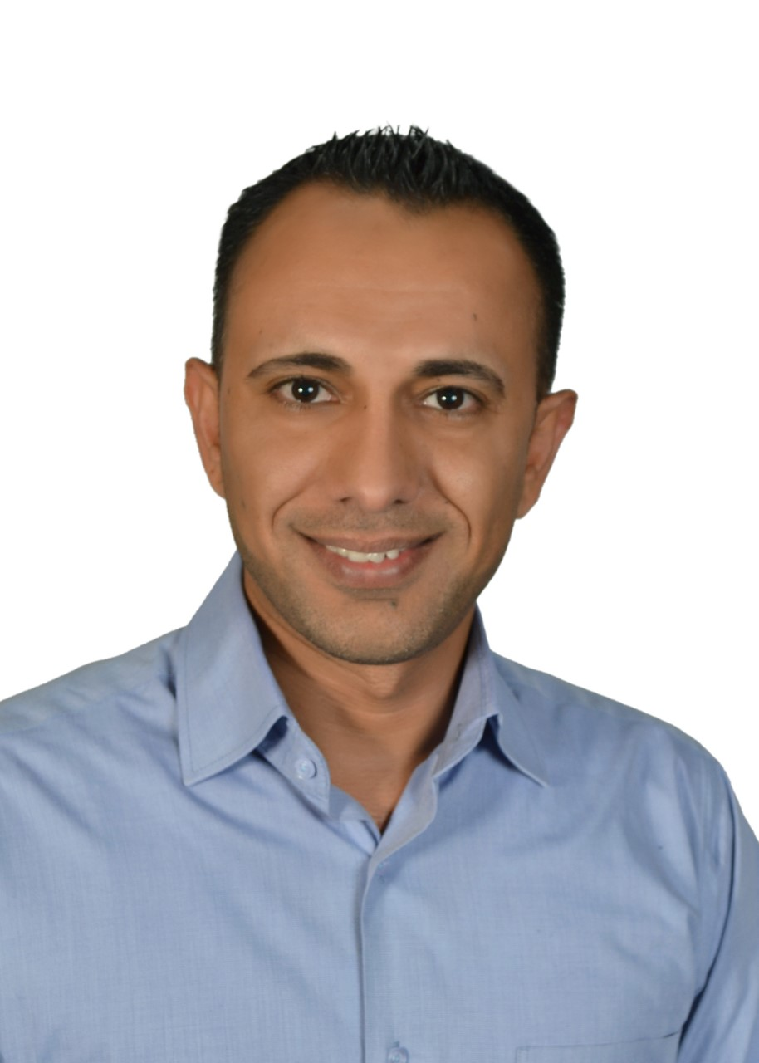

|  |
| --- |
| **mo'TAZ KAMEL ABDALJALEEL AL ZOBI** |

|  |  |
| --- | --- |
| **Personal information** | |
|  | Title: Dr. |
|  | Academic Rank:Assistant Professor |
|  | Date & Place of Birth: 12/07/1984 Alsalt |
|  | Nationality: Jordanian |
|  | Address: Alsalt –Allan |
|  | Phone No.: 0795303930 |
|  | e-mail:motaz@aau.edu.jo |

|  |  |  |  |  |
| --- | --- | --- | --- | --- |
| **Academic qualifications** | | | | |
| Degree | Major | Duration  (From-To) | University | Country |
| Bachelor | Accounting | 2006-2009 | Al-Zaytoonah University of Jordan | Jordan |
| Master | Accounting | 2009-2011 | University of Banking and Financial Sciences | Jordan |
| Ph.D | Accounting | 2011-2016 | The World Islamic Sciences and Education University | Jordan |

|  |  |  |  |  |
| --- | --- | --- | --- | --- |
| **Teaching experience** | | | | |
| Duration | Rank | Institution | Department/Faculty | Country |
| 02/2017 –Present | Assistant Professor | Amman Arab University | Accounting Department / Faculty of Business | Jordan |

|  |  |  |  |  |
| --- | --- | --- | --- | --- |
| **Other experience** | | | | |
| Duration | Rank | Institution | Department/Faculty | Country |
|  |  |  |  |  |
|  |  |  |  |  |
|  |  |  |  |  |
|  |  |  |  |  |
|  |  |  |  |  |
|  |  |  |  |  |
|  |  |  |  |  |

|  |  |  |  |  |  |  |
| --- | --- | --- | --- | --- | --- | --- |
| **Publications** | | | | | | |
| **Journals** |  | |  | | | |
| Author/s  (In Order) | Title | | Journal | | Vol./No. | Publication Date |
| Borhan Omar Al-dalaien, Ala Hussein al-bawwat, Zeyad Almatarneh, Mo’taz Kamel Al Zobi, Mazen Alomari, Basman Omar al-dalayeen | Auditing Practices in Banks: an Empirical Study of Jordan | | International Journal of Procurement Management | |  | 2022 |
| Zeyad Almatarneh,  Baker Akram Falah Jarah,  Almothanna Abu-Allan,  Nimer Alslihat,  Mo'taz Kamel Al Zobi, | The impact of Cash Liquidity Risk Management on the Commercial Banks Performance In The Light Of the International Accounting | | Academy of Accounting and Financial Studies Journal | | Volume 26, Special Issue 2, | 2022 |
| Al Zobi, Mo’taz Kamel,. Al-Dhaimesh, Othman Hel | The impact of cash flow statement components on stock volatility: Evidence from Qatar | | Investment Management and Financial Innovations | | Volume 18, Issue 2 | 2021 |
| Ala Hussein Albawwat, Ammar Almansour, Nahed Habis Alrawashedh  mo'taz al zobi | [The Effect of Board of Directors and Audit Committee Characteristics on Company Performance in Jordan‏](javascript:void(0))  [**https://ideas.repec.org/a/jfr/ijfr11/v11y2020i6p10-24.html**](https://ideas.repec.org/a/jfr/ijfr11/v11y2020i6p10-24.html) | | International Journal of Financial Research | | 6 | 2020 |
| Nahed Habis , Asiya Chaudhary, Al Zobi, Mo'taz | Procedures for the adoption of the International Financial Reporting Standards for property, plant and equipment in an organization  https://www.psychosocial.com/article/PR2020929/30721/ | | International Journal of Psychoscial Rehabilitiation | | Vol. 24, Issue 02 | 2020 |
| Nahed Habis Alrawashedh, Dr Abdelrahim Kadomi, Zeyad Almatarneh, mo'taz al zobi | EXTERNAL AUDITOR'S RESPONSIBILITY TO THE DETECTION OF INACCURACY AND FRAUD IN THE FINANCIAL STATEMENTS: AN EMPIRICAL STUDY  <https://www.researchgate.net/publication/340066135_EXTERNAL_AUDITOR%27S_RESPONSIBILITY_TO_THE_DETECTION_OF_INACCURACY_AND_FRAUD_IN_THE_FINANCIAL_STATEMENTS_AN_EMPIRICAL_STUDY> | | International Journal of Advanced Science and Technology | | Vol 29 No 3s | 2020 |
| Dhaimesh, Othman,. Al Zobi, Mo'taz Al- | The effect of sustainability accounting disclosures on financial performance: an empirical study on the Jordanian banking sector <https://businessperspectives.org/images/pdf/applications/publishing/templates/article/assets/11854/BBS_2019_02_Al-Dhaimesh.pdf> | | Banks and Bank Systems | | 14 / 2 | 2019 |
| Al Zobi, Mo'taz,. Shubita, Mohammad,.Alomary, Mazen,.Almatarneh, Ziyad,.Alrawashdeh, Nahed | The Impact of Board and Audit Committees Characteristics on the Credit Risk in Jordanian Commercial Banks  [**https://www.researchgate.net/profile/Mohammad_Shubita/publication/337447070_The_Impact_of_Board_and_Audit_Committee_Characteristics_on_the_Credit_Risk_in_Jordanian_Commercial_Banks/links/5dd818b392851c1feda73e09/The-Impact-of-Board-and-Audit-Committee-Characteristics-on-the-Credit-Risk-in-Jordanian-Commercial-Banks.pdf**](https://www.researchgate.net/profile/Mohammad_Shubita/publication/337447070_The_Impact_of_Board_and_Audit_Committee_Characteristics_on_the_Credit_Risk_in_Jordanian_Commercial_Banks/links/5dd818b392851c1feda73e09/The-Impact-of-Board-and-Audit-Committee-Characteristics-on-the-Credit-Risk-in-Jordanian-Commercial-Banks.pdf) | | International Journal of Business Management and Economic Research (IJBMER) | | 162/ 2 | 2018 |
| Al-Shobaki,Younes,. Shubita, Mohammad,.Almatarneh,Zeyad,. Al Zobi, Mo'taz | The Role of Internal Auditor in Limiting the Money Laundering in the Jordanian Commercial Banks  [**https://serialsjournals.com/abstract/82262_ch_61_f_-_zeyad---ijaber.pdf**](https://serialsjournals.com/abstract/82262_ch_61_f_-_zeyad---ijaber.pdf) | | **International Journal of Applied Business & Economic Research** | | 16 | 2018 |
| Alrawashdeh,Nahed,.Alomary, Mazen,. Al Zobi, Mo'taz | The Role of Forensic Accounting in the face of Accounting Fraud practices and their Impact on the Financial Statements | | **Ciencia e TecnicaVitinicola Journal** | | 33/ 2 | 2018 |
| Alomary, Mazen,. Al Zobi, Mo'taz,.Alrawashdeh, Nahed | [The Impact of Corporate Governance and Ownership Structure on](https://www.sciencedirect.com/science/article/pii/S0929119907000302) the Liquidity Risk in Jordanian Commercial Banks  **https://www.researchgate.net/publication/328281452_The_Impact_of_Corporate_Governance_and_Ownership_Structure_on_the_Liquidity_Risk_in_Jordanian_Commercial_Banks** | | **interciencia journal** | | 43/ 4 | 2018 |
| Almatarneh, Ziyad,.Alslihat, Nimer,. Al Zobi, Mo'taz,. Shireen Al-Ali | Effect of Using the Financial Ratios on Explaining the Accounting Profit Power in Making the Financial Decisions in the Jordanian Commercial Banks  [**https://www.researchgate.net/publication/323113566_Effect_of_using_the_financial_ratios_on_explaining_the_accounting_profit_power_in_making_the_financial_decisions_in_the_Jordanian_commercial_Banks**](https://www.researchgate.net/publication/323113566_Effect_of_using_the_financial_ratios_on_explaining_the_accounting_profit_power_in_making_the_financial_decisions_in_the_Jordanian_commercial_Banks) | | **International Journal of Economic Research** | | 14/ 20 | 2017 |
| Alslihat, Nimer,. Shubita, Mohammad,. Al Zobi, Mo'taz,.Alomary, Mazen | The Impact of the Board Structure on the Earnings Quality in Jordanian Commercial Banks  [**http://jjoas.asu.edu.jo/index.php/JJAS-H/issue/view/21/131**](http://jjoas.asu.edu.jo/index.php/JJAS-H/issue/view/21/131) | | **The Jordan Journal of Applied Science** | | 22/1 | 2020 |
|  | | | | | | |
| **Conferences** |  | | | | | |
| Author/s  (In Order) | Title | Conference | | Country | | Date |
| Al Zobi, Mo'taz,. Alrawashdeh, Nahed | **The Impact of Applying Corporate Governance Rules on the Operational Risks in Jordanian Commercial Banks** |  | | Jordan | | 13-14April 2019 |
| Alomary, Mazen,.alsidatm ziad., Al Zobi, Mo'taz,.Alrawashdeh, Nahed | **Activity Based Cost Systems and Improving of Pricing Decisions: An Empirical Study in Industrial Corporations Listed in Amman Stock Exchange**. |  | | Jordan | | 07-08April 2019 |
|  | | | | | | |

|  |  |
| --- | --- |
| **Courses that have been taught Before** |  |
| Principles of Accounting/1 | Income Tax Accounting |
| Principles of Accounting/2 | Intermediate Accounting/1 |
| Cost Accounting | Auditing |
| Managerial Accounting | Advanced accounting |
| Corporate Accounting | International Accounting Standards |
| Financial Accounting Theory | International Accounting |
| Financial Statement Analysis |  |

|  |
| --- |
| **Memberships OF Scientific and professional societies** |
|  |
| **university Committees** |
| Quality Assurance Committee  Library Committee  University’s website Committee  Marketing Committee  Students affairs Committee  Member of the collogue Council |

|  |
| --- |
| **Workshops Attended** |
| 1- E-learning and re-electronic courses.  2- Achievement tests course and its applications.  3- Course preparation  4- Preparing course plans and linking them to the education and program outputs. |
| **Workshops Offered** |
| * Income & Sales Tax Law course |

|  |
| --- |
| **Research interests** |
| Corporate Governance, auditing, Sustainability Accounting |
| **Languages** |
| Arabic , English |

|  |
| --- |
| **Other Community activities** |
|  |
| **Awards received** |
|  |

|  |  |
| --- | --- |
| **Graduate Students Supervision** | |
| Student Name | Thesis Title |
| **Ali Mohammed Ali Alrayyan** | **THE IMPACT OF AUDIT COMMITTEES CHARACTERISTICS ON THE FINANCIAL PERFORMANCE OF JORDANIAN COMMERCIAL BANKS** |
|  | |
| **References** | |
|  | |