Date 03/10/2021
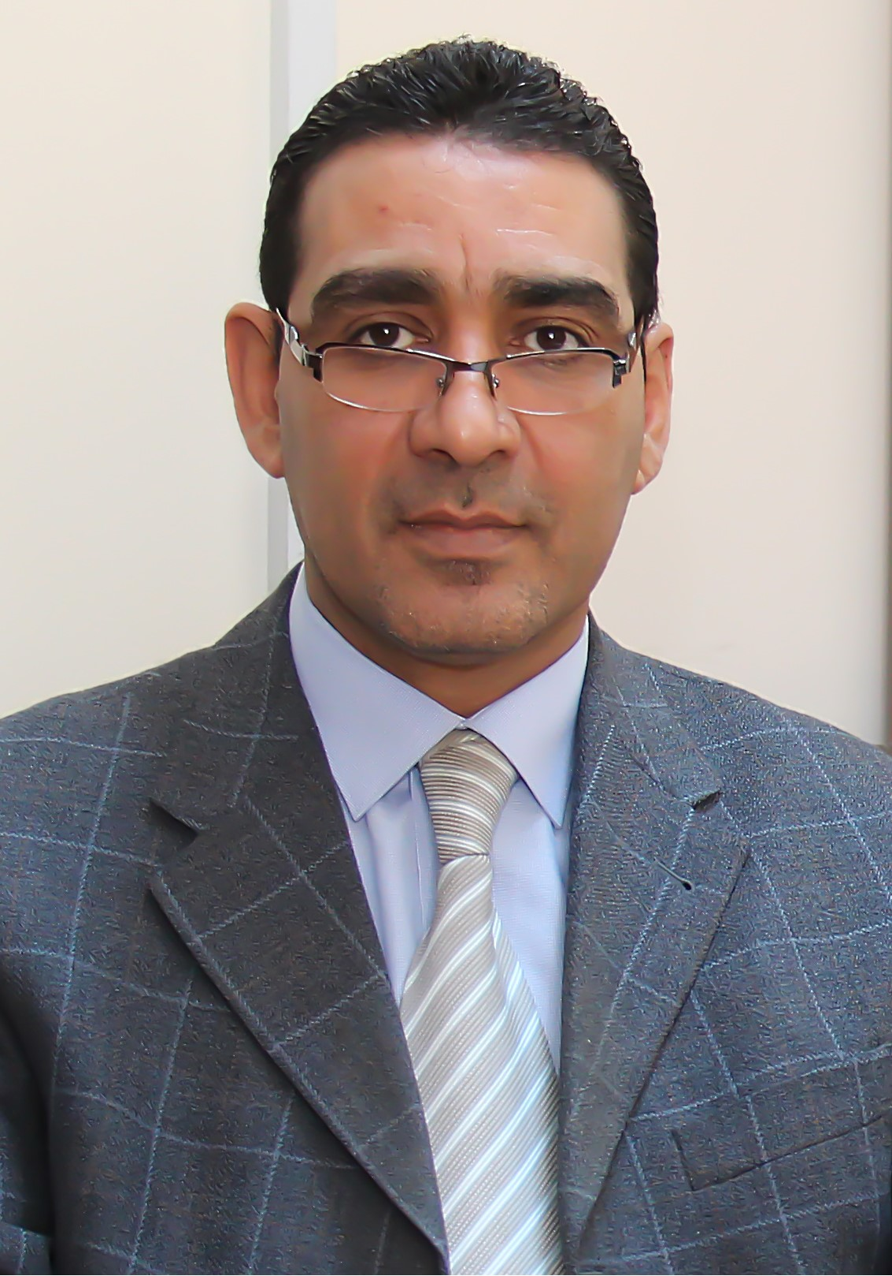Photo

omar asad mohamd ahmad

Personal information
Title: Faculty Member – Civil Engineering Department
Academic Rank: Associate Professor
Date & Place of Birth: 04/09/1969 – Jordan / Zarqa.
Nationality: Jordanian
Address: Jordan – Amman/ Shefa Badran / Rateb Alawamleh St. 28-2
Phone No.: 00962797963630
E-mail: oahmad@aau.edu.jo

Academic qualifications
Degree | Major | Duration  (From-To) | University | Country
PhD | Engineering Hydrogeology (Water and Environmental Engineering) | 1995-1999 | Russian Friendship University | Russia
MSc | Engineering Geology | 1993-1995 | Russian Friendship University | Russia
BSc | Engineering Geology | 1987-1993 | Russian Friendship University | Russia

Teaching experience
Duration | Rank | Institution | Department/Faculty | Country
2004-2011 | Assistant Professor | Sebha University | Department of Civil Engineering / Faculty of Engineering | Libya
2011-2014 | Assistant Professor | Zarqa University | Department of Civil Engineering / Faculty of Engineering Technology | Jordan
2014-2017 | Associate Professor | Zarqa University | Department of Civil Engineering / Faculty of Engineering Technology | Jordan
2017-2022 | Associate Professor | Amman Arab University | Department of Civil Engineering / Faculty of Engineering | Jordan

Other experience
Duration | Rank |  | Institution |  |  | Department/Faculty |  |  | Country
2014-2015 | Associate Professor |  | Al-Albyat University |  |  | Department of Civil Engineering / Faculty of Engineering |  |  | Jordan
2001-2004 | Senior Engineer |  |  | Union Engineering Group |  | Soil and Engineering Geology Site Investigation |  |  | Jordan
1999-2001 | Assistant Professor |  | Hydrology Institute |  |  | Hydrological and Environmental Studies. |  |  | Russia
Publications
Journals
Author/s  (In Order) |  | Title |  |  |  |  | Journal | Vol./No. |  | Publication  Date
Omar Asad Ahmad |  | The feasibility of Heavy Metals Removal from Drinking Water Sources Containing Sulfide Ions by Pillared White Sand of Different Grains Size |  |  |  |  | Polish Journal of Environmental Studies | Accepted  January 07, 2022 |  | Accepted  January 07, 2022
Omar Asad Ahmad,  Gazzaz N.,  Al Shebani A. |  | Ground water quality in Wadi Shati (Libya): Phyisco-chemical analysis and environmental implications |  |  |  |  | Journal of Water and Land Devolvement | Accepted  August 30, 2021 |  | Accepted  August 09, 2021
Omar Asad Ahmad |  | Strength behavior of transitional group A-2-7 soil stabilized with fly ash and lime powder |  |  |  |  | Archives of Mining Sciences | Vol 66 , Issue 4, pp.511-522 |  | 2021
Al-Rawashdeh M., Ashraf S., Omar Ahmad, Ahmed Y., Isam H. |  | Assessment of Environmental Factors on corrosion in Reinforced Concrete with Calcium Chloride. |  |  |  |  | Journal of Civil and Architecture | Vol .9 Issue 6, pp. 1985-1995 |  | - 1st. September, 2021
Omar Asad Ahmad  Sami Ayyad |  | SECONDARY TREATED WASTEWATER AS A CONCRETE COMPONENT AND ITS IMPACT ON THE BASIC STRENGTH PROPERTIES OF THE MATERIAL |  |  |  |  | Archives of Civil Engineering | Vol.67  Issue 1,  pp.571-583 |  | 31/03/2021
Sami Ayyad,  Omar Asad Ahmad |  | THE USE OF SAND COLUMNS IN THE REINFORCEMENT OF WEAK LAYERS IN ROAD ENGINEERING |  |  |  |  | Archives of Civil Engineering | Vol.67  Issue 1,  pp.527-538 |  | 31/03/2021
Omar Asad Ahmad,  Abdel Majeed Al Kassasbeh, Mohammed Abed Al Rawashdeh |  | FABRICATION OF POLYMER CONCRETE OF LIGHT WEIGHT AND HIGH PERFORMANCE |  |  |  |  | International Journal of GEOMATE | Vol.20  Issue 77,  pp.116-122 |  | Jan., 2021
Omar Asad Ahmad |  | THE USEFULNESS OF CONSTRUCTION AND DESTRUCTION WASTE AS RECYCLED AGGREGATES IN CONCRETE |  |  |  |  | International Journal of GEOMATE | Vol.19, Issue 75, pp.8-18 |  | Nov., 2020
Omar Asad Ahmad |  | Production of high-performance silica fume concrete |  |  |  |  | American Journal of Applied Sciences | 14 (11): 1031.1038 |  | 2017
Omar Asad Ahmad, Awad M.T. |  | Effects of Different Environments on Reinforcement Concrete Corrosion. |  |  |  |  | American Journal of Environmental Sciences | 13 (4) : 307-314 |  | 2017
Omar Asad Ahmad |  | Using Crump Rubber (CR) of Scrap Tire in Hot Mix Asphalt Design. |  |  |  |  | American Journal of Applied Sciences | 14 (2): 274.285 |  | 2017
Nafi Abdel Rahman Youssef, Omar Asad Ahmad |  | Soil Improvement by Marble Stone Slurry Wastes. |  |  |  |  | Electronic Journal of Geotechnical Engineering | Vol. 20, Bund. 8. pp. 2221-2233 |  | 2015
Omar Asad Ahmad |  | Determination of macro and micronutrients levels in organic manure soils and irrigation water. |  |  |  |  | Journal of Civil and Environmental Research | Vol.7, No.2,  (Paper) 2224-5790, (Online) 2225-0514  pp.16-22 |  | 2015
Omar Asad Ahmad, Awad M.T |  | The effects of polypropylene fibers additions on compressive and tensile strengths of concrete. |  |  |  |  | International Journal of Civil and Environmental Engineering | Vol.37, Issue.1, pp.1365-1372. |  | March 2015.
Al Rawashdeh M., Omar Asad Ahmad |  | The environmental impacts of calcium chloride addition to cement on reinforcing steel corrosion |  |  |  |  | Journal of Chemistry and Materials Research | Vol.3 No.9  pp.137-147. |  | 2013
Omar Asad Ahmad |  | The effect of organic waste addition on biochemical factors and availability of phosphorus in desert soils. |  |  |  |  | Journal of Environment and Earth Science. | Vol 3, No 4, pp. 67-73 |  | November, (2013)
Omar Asad Ahmad, Al Rawashdeh M., Al Omari O. |  | Study of Sandy Silica Properties in Area of Edree (Libya) and the Possibility of Using in Various Engineering Industries |  |  |  |  | Journal of Environmental and Engineering Science and Technology A. | Vol 20  pp. 1137- 1141 |  | September, 2012.
Omar Asad Ahmad, Al Rawashdeh M |  | The Possibility of Agricultural Drainage Water Reuse in Agricultural Project |  |  |  |  | Journal of Environmental and Engineering Science and Technology A. | Vol 20  pp. 1096-1100 |  | September 20, 2012.
Omar Asad Ahmad |  | Mineralization of Organic Nitrogen in Soil |  |  |  |  | Sharjah Journal for Pure and Applied Science | Vol. 4, no. 3, pp. 17-33 |  | (Oct. 2007)  ISSN: 1645-1811
Conferences
Author/s  (In Order) |  | Title |  |  | Conference |  |  | Country |  |  | Date
Omar Asad Ahmad |  | The Effect of Chlorination and Sand Grain Size on Adsorption-Retention of Some Heavy Elements in Sulfide Water. |  |  | 1st International Conference on Water Security. |  |  | Canada-Toronto |  |  | June 2018
Omar Asad Ahmad |  | Improvement of Compressive and Tensile Strengths of Concrete Using polypropylene Fibers. |  |  | ICCEE 2015 : 8th International Conference on Civil and Environmental Engineering |  |  | USA – Miami/  Florida |  |  | March 2015
Omar Asad Ahmad |  | Study of Sandy Silica Properties in Area of EDREE (Libya) And the Possibility of Investment in Different Engineering Industry, |  |  | 10th International Conference of Jordanian Geologists Association in association with 7Th International Symposium on Middle East Geology |  |  | Amman, Jordan. |  |  | 2011
Omar Asad Ahmad, Suleiman M.S. |  | Environmental Study of Underground Water Quality in Wadi Arial Project and Evaluate its Impacts as Corrosive Environment |  |  | 2ed Zarqa Engineering Science Conference, Zarqa Privet University and Jordanian Engineering Association. |  |  | Zarqa, Jordan. |  |  | 2010
Omar Asad Ahmad |  | Study of Underground Water Properties in Wadi Alshati Region and Estimate Deterioration its Quality |  |  | 2ed Zarqa Engineering Science Conference, Zarqa Privet University and Jordanian Engineering Association. |  |  | Zarqa, Jordan. |  |  | 2010
Omar Asad Ahmad, Abdalah M.A. |  | Mineralization of Organic Phosphorous in Soil. |  |  | 1st International Conference “Organic Agriculture- Limitations and Future” |  |  | Ain Shams University, Egypt. |  |  | 2010
Omar Asad Ahmad, Faruj F. |  | Recycling solid residual of Building materials in Building manufacture, |  |  | 1st Conference of Architecture in Deserts Regions, |  |  | Sebha, Libya. |  |  | 2008
Omar Asad Ahmad, Ramadan E. |  | The Impact of Irrigation Water on Soil Degradation Of Wadi-Alshati Region |  |  | Desert and Desertification conference. |  |  | Sebha, Libya. |  |  | 2007
Omar Asad Ahmad |  | Study of Clay Rocks Minerals in Ashkada and Brack- Alshati Regions |  |  | 3th building materials Conference. |  |  | Mesrata, Libya. |  |  | 2006.
Omar Asad Ahmad |  | Using Engineering Geological Secondary Structures in Determining Petroleum Reservoirs |  |  | 9th Mediterranean petroleum Conference and Exhibition |  |  | Tripoli, Libya. |  |  | 2006.

Memberships OF Scientific and professional societies
1. Member, JEA Jordan Engineer Association, Jordan
2. Member of International Society for Development and Sustainability (ISDS) Fukuoka, Japan.
3. Reviewer for Journal of Applied Science, Sebha University.
4. Reviewer for Journal of Earth and Environmental Science, USA, David Publishing Company.

university Committees
- Member of Quality Assurance Council, Amman Arab University, 2017-Present.
- Member of Scientific Research Council, Amman Arab University, 2017-2018.
- Member of Competency Test Committee, Amman Arab University, 2017-2019.
- Member of Sustainability Council, Amman Arab University, 2020- Present.
- Quality Officer of Faculty of Engineering and Technology, Zarqa University, Jordan, 2011-2014.
- Member of the Committee for the development of graduate programs at Zarqa University, Jordan.
- Head of Examination committees in Faculty of Engineering and Technology, Sebha University. 2006-2010.
- Member of many committees in the Civil @ Environmental Engineering Department at Sebha University.
- Member of promotion committees in the Environmental Engineering Department at Sebha University.
- Member of promotion committees in the Civil Engineering Department at Sebha University.

Research interests
1. Recycling, Reuse of building material in new green civil engineering.
2. Recycling of wasted water in varies purposes in civil supplying.
3. Use of natural green material in new Architectural Design.
4. Soil improvement and contamination investigation.

Languages
1. Arabic
2. Russian
3. English

References
1. Full Professor Khaled Irkhais Al Tarawneh. Dean of Engineering Faculty, Amman Arab University.
2. Full Professor Taisir Hasan Ismail. Dean of Faculty Engineering Technology, Zarqa University.
3. Full Professor Abdel Salam Akash. Head of Civil Engineering Department, Sebha University.
4. Full Professor Mamsour Eweidat Salem, Vice President Sebha University, Sebha University.

