Date 5/10/2021
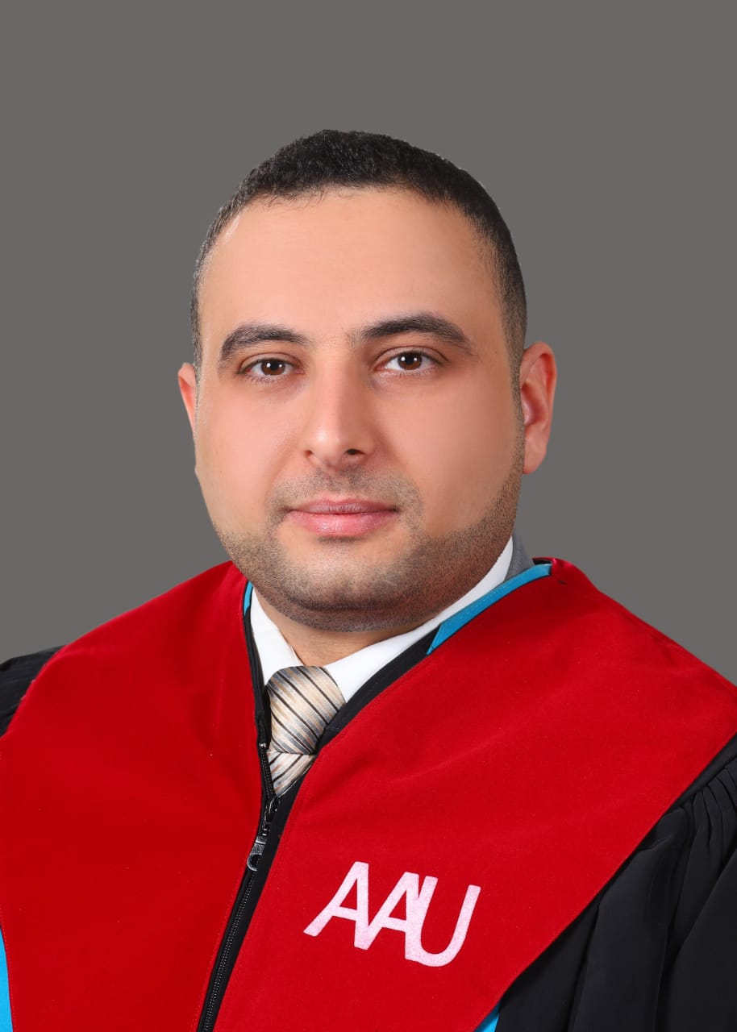

Dr. Mohammad Fawzi Zaki Ismail

Personal information
Title: Lecturer
Academic Rank:Assistant Professor
Date & Place of Birth: 19/4/1989- Makka/ Saudi Arabia
Nationality: Jordanian
Address: Al-Bunyat- Amman
Phone No.: 0788728770
e-mail:

Academic qualifications
Degree | Major | Duration  (From-To) | University | Country
PhD | Mechanical Engineering / thermal science and renewable energy | 2016-2020 | Northumbria | United Kingdom
Master | Mechanical Engineering | 2012-2015 | The University of Jordan | Jordan
Bachelor | Mechanical Engineering/ Thermal Science and Hydraulic Machines | 2007-2012 | Al Balqaa Applied University | Jordan

Teaching experience
Duration | Rank | Institution | Department/Faculty | Country
2020-recent | Assistant professor | Amman Arab University | Renewable Energy Engineering | Jordan
1/6-1/9 2020 | Lecturer | AL-Khwarizmi Collage | Mechanical Engineering | Jordan
1/2/-3/6/2020 | Lecturer | Al- Zaytoneeh University | Mechanical Engineering | Jordan

Other experience
Duration | Rank | Institution | Department/Faculty | Country

Publications
Journals
Author/s  (In Order) | Title |  | Journal | Vol./No. | Publication Date
Mohammad Ismail, Awni H.Alkhazaleh, JafarMasri, Abdullah Masoud Ali, Malek Ali | Experimental and Numerical Analysis of Paraffin Waxes during Solidification inside Spherical Capsules |  | Thermal Science and Engineering Progress | - | 2021
Sol-Carolina Costa, Khamid Mahkamov, Murat Kenisarin, Mohammad Ismail, Kevin Lynn, Elvedin Halimic, David Mullen | Solar salt latent heat thermal storage for a small solar organic Rankine cycle plant |  | Journal of Energy Resources Technology | 142 | 2020
SOL-CAROLINA COSTA, MOHAMMAD ISMAIL, MURAT KENISARIN, KHAMID MAHKAMOV, DAVID MULLEN, ELVEDIN HALIMIC, KEVIN LYNN | COMPARATIVE STUDY OF TWO TYPES OF MEDIUM TEMPERATURE PHASE CHANGE MATERIALS |  | WIT Transactions on Ecology and the Environment | 237 | 2019
Conferences
Experimental and numerical study on melting of solar salt in a finned metallic container | Experimental and numerical study on melting of solar salt in a finned metallic container | ASME International Mechanical Engineering Congress and Exposition |  | USA | 2018/11/9

Books
Author/s  (In Order) | Title | Publisher | Edition | Date
Memberships OF Scientific and professional societies
- Jordan Engineering association.

university Committees
- Library.
- Website.
- ELearning.
- Exams.
- Training.
- Student’s affairs.
- Business Development.
- Initiatives and projects.
Workshops Attended
- Firefighting.
- HVAC.
Workshops Offered
Research interests
Phase change Material, Thermal Management, and Latent heat thermal energy storage system

Languages
Arabic, English

Other Community activities
Awards received

Graduate Students Supervision
Student Name | Thesis Title
References
• Dr. Islam Shyha
islam.shyha@northumbria.ac.uk
Tel: +44 0191 243 7834
abadran@philadelphia.edu.jo
• Prof. Dr. Nabil Beithou
beithounabil@yahoo.com
Tel: +962790764692

