Date: 15/09/2020
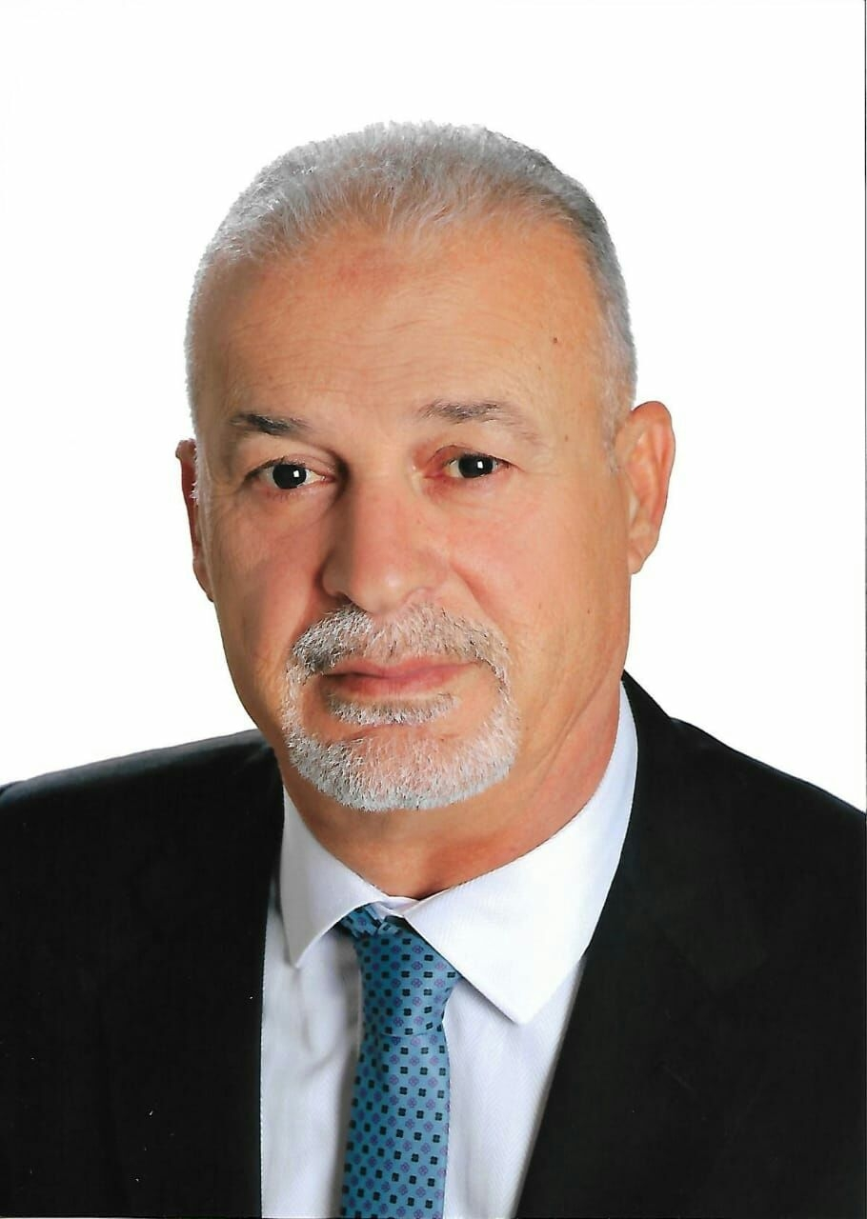
Photo

NABIL MUSTAFA SALAMEH AL-FAYYOUMI

Personal information
Title: Faculty Teaching Member
Academic Rank: Teacher
Date & Place of Birth: Aqbat Jabr – 6/3/1959
Nationality: Jordanian
Address: Amman – Jubaiha - Zaytona
Phone No.: 0795070086 / 0785509293
e-mail: n.fayyoumi@aau.edu.jo

Academic qualifications
Degree | Major | Duration  (From-To) | University | Country
M.Sc. | Engineering Projects Management | 2016-2017 | Isra University | Jordan
B.Sc. | Civil Engineering | 1977-1981 | Mosul University | Iraq

Teaching experience
Duration | Rank | Institution | Department/Faculty | Country
2019-2020 | OWNER & Certified professional Trainer | EEMC | Private sector | Jordan

Other experience
Duration | Rank |  |  |  | Institution |  | Department/Faculty |  |  | Country
2014-2019 | Owner & G.M |  |  |  | CCC |  | Private Sector |  |  | Jordan
2014-2020 | Projects Manager |  |  |  | NACE |  | Private Sector |  |  | Jordan
201202012 | Projects Coordinator |  |  |  | ASTRACO |  | Private Sector |  |  | Jordan
2011-2012 | Projects Manager |  |  |  | NACE |  | Private Sector |  |  | Jordan
2005-2010 | Projects Manager |  |  |  | JMCREI |  | Private Sector |  |  | Jordan
2004-2005 | Project Manager |  |  |  | D&P |  | Private Sector |  |  | Jordan
1999-2004 | Projects Manager |  |  |  | ALFADEL |  | Private Sector |  |  | Jordan
1992-1999 | Resident Engineer |  |  |  | PLANS |  | Private Sector |  |  | Jordan
1991-1992 | Senior Designer |  |  |  | Al-SHAYEB Office |  | Private Sector |  |  | Jordan
1987-1991 | Site Manager |  |  |  | UECC |  | Private Sector |  |  | Iraq
1986-1987 | Site Engineer |  |  |  | IECC |  | Private Sector |  |  | Iraq
1982-1986 | Executive Engineer |  |  |  | DSEO |  | Private Sector |  |  | Iraq
1981-1982 | Fabrication Engineer |  |  |  | MOTACO |  | Private Sector |  |  | Kuwait
Publications
Journals
Author/s  (In Order) |  | Title |  | Journal |  | Vol./No. |  | Publication Date
Conferences
Author/s  (In Order) |  | Title | Conference |  |  | Country |  |  | Date
JEA RDC Estimator Software Towards a Quality Step Jordan March 2019

Books
Author/s  (In Order) | Title | Publisher | Edition | Date

Memberships OF Scientific and professional societies
- Iraqi Engineers Association.
- Jordanian Engineers Association.
- Jordanian Construction Contractors Association.
university Committees
Workshops Attended
Workshops Offered
- Engineering Time Management.
- Engineering Quality Management.
- Engineering Cost Management.
- Project Risk Management
- Value Engineering Management.
- Advanced Engineering Economy.
- Lean Six Sigma management.
- Quantity Surveying of projects.
- Advanced Statistics.
- Integration & coordination of engineering drawings.
- Arbitration in Financial Disputes according to FIDIC.

RDC Software for construction projects cost estimation, performance and forecasting.

Research interests
Languages
Arabic – Excellent command
English – V. good command

Other Community activities
Awards received
Graduate Students Supervision
Student Name | Thesis Title
References
- Dr. Khalid Tarawneh – Amman Arab University.
- Dr. Rami Maher Al-sameraee – Isra University.
- Dr. Ibrahim Hadithi – Isra University.
- Dr. Mohammad Hiasat – Jordan University.
- Dr. Adel Hado – Isra University.
- Dr. Rami Hadithi – Jordan University.
- Dr. Sufian Hayajneh – Isra University.

