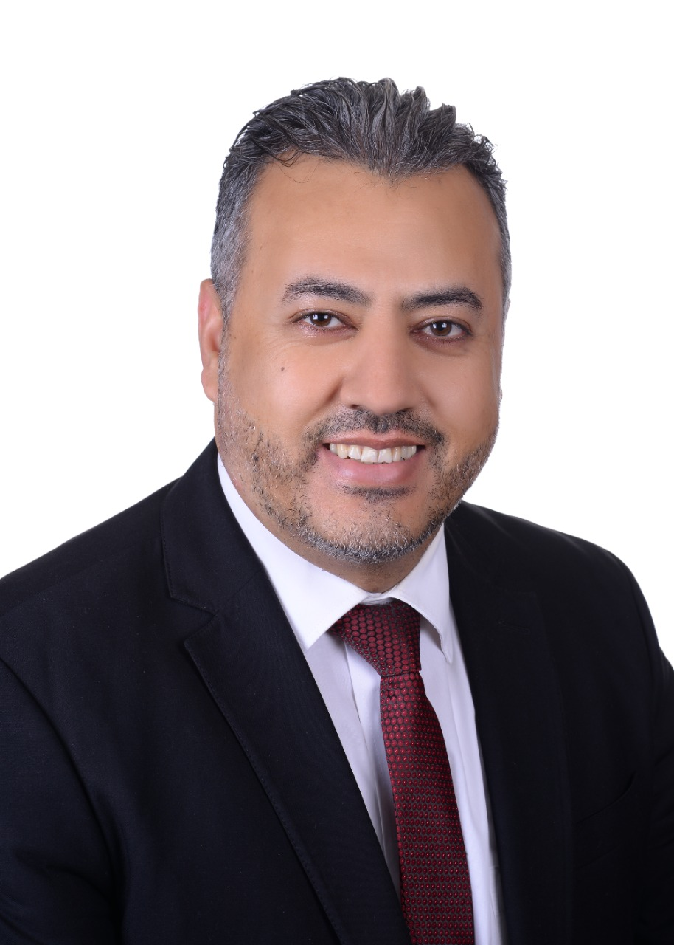
RESUME

Dr. MAHMOOD A. M. ABU SHAREAH

CURRENT ADDRESS
Address | : | Umm Alsummaq – Amman.
Mobile | : | +962 775839094
Email | : | mahmood_abushareah@yahoo.com

PERSONAL PARTICULARS
Date of Birth | : | 28th August 1979
Nationality | : | Jordanian.
Marital Status | : | Married.

EDUCATIONAL BACKGROUND
Level | : | Doctor of Philosophy (PhD).
Major | : | Islamic Finance and Banking.
Name of Institution | : | Othman Yeop Abdullah Graduate School of Business / Islamic Business School University Utara Malaysia (UUM).
Location | : | Kedah, Malaysia.
Completion Date | : | 2016.
Thesis Title | : | The Practice Of Mushārakah Mutanāqisah In Islamic Banks From Shari’ah Perspectives: A Comparative Study Between Malaysia And Jordan. (Thesis Written in English).
Level | : | Master's Degree.
Current CGPA | : | 3.150
Major | : | Master Of Science in Islamic Banking and Finance.
Name of Institution | : | International Islamic University Malaysia (IIUM).
Location | : | Gombak, Malaysia.
Completion Date | : | 2013.
Thesis Title | : | Contemporary Applications of Mudarabah Investment Account. (Thesis Written in English).
Level | : | Master's Degree.
Current CGPA | : | 3.46
Major | : | Islamic Studies (Quranic and Sunnah).
Name of Institution | : | Universiti Kebangsaan Malaysia (UKM).
Location | : | Bangi, Selangor, Malaysia.
Completion Date | : | 2006.
 |  | [
Level | : | Bachelor's Degree.
Current CGPA | : | 2.662
Major (Minor) | : | Islamic Studies.
Name of Institution | : | International Islamic University Malaysia (IIUM).
Location | : | Gombak, Malaysia.
Completion Date | : | 2004.

ACHIEVEMENTS AND MEMBERSHIPS
Courses Attended:

- Top Training Programme I and II from 16-18 August 2005 at Sri Warisan Resort, Ayer Keroh, Melaka.
- A Course: Working Ethics In Islam (18-20 December 2004) at Swiss Garden Resort andSPA, Beserah, Pahang. Malaysia.

Participation:

- Gold Dinar Seminar. (25 November 2011), International Islamic University Malaysia (IIUM).
- One – Day Seminar on Understanding Riba.(7 October 2011),Kulliyya of Economic and Management Sciences at International Islamic University Malaysia (IIUM).
- Da’wah Courses Organised By O.I.C. and In Collaboration With: International Islamic University Malaysia.(9-10 April 2005), International Islamic University Malaysia (IIUM).
- The International Seminar on Islamic Thought.(7-9 December 2004),National University Malaysia (UKM), Bangi.

Handled Tasks:

- A Committee member of The National Seminar On “Islam Hadhari and Ummah Development”. (24th-26th March, 2006), Pan Pacific Hotel, KLIA, Malaysia.
- Master of ceremony for a Business Seminar, Marketing and Public Relations Secretariat of Malaysia International Halal Showcase 2005. (28th -31st July, 2005).
- Master of ceremony and committee member for the farewell dinner for the Islamic Counselor, Royal Embassy of Saudi Arabia. (9th June, 2005), Le Meridien hotel, Kuala Lumpur, Malaysia.
- Kursus Dakwah Majlis OIC. (9th-10thApril, 2005), International Islamic University Malaysia.
- Master of ceremony and committee member of The International Islamic Confederation of Labour (IICL) 2005 conference.), Pan Pacific hotel, KLIA , Malaysia.
- Master of Ceremony for the Official Launching Ceremony of the 2ndMalaysia International Halal Showcase 2005. (10thDecember, 2004), Kuala Lumpur – Malaysia.
- Moderator for the International Muslim Women’s Textile and Apparel Conference 2004 (2nd-3rdDecember, 2004), Kuala Lumpur – Malaysia.
- International Reception Committee member, Marketing and Public Relations Secretariat of Malaysia International Halal Showcase.(14th -18th August, 2004), Kuala Lumpur – Malaysia.
- Translator for the Jordanian official delegations during their meetings with the Malaysian side, in addition, attendance of many political meetings, conferences and exhibitions related to economic, tourism, military and culture, as a representative of Jordanian Embassy to coordinate with the Malaysian side.

Committee Memberships at Amman Arab University:

- A committee member of conferences and workshops at Faculty of Business for the academic year 2017/2018.
- A committee member of examinations at Faculty of Business for the academic year 2017/2018.
- A committee member of selecting the distinguished staff for administrative and technical affairs at university level for the academic year 2017/2018.
- A committee member of the seventh quality standard/society and international relations at Faculty of Business for the academic year 2018/2019.
- A committee member of marketing (locally and internationally) at university level for the academic year 2018/2019 and 2019/2020.
- A board member of Faculty of Business’s board for the academic year 2018/2019.
- The department of finance, control, and financial auditing’s representative at Faculty of Business for the academic year 2018/2019.
- A committee member of Cultural at Faculty of Business for the academic year 2019/2020.
- A committee member on building external relationships at faculty of Business for the academic year 2019/2020.

Publications in Journals
- Regulatory Framework and Practice of Musharakah Mutanaqisah in Islamic Banks of Jordan, Journal of Islamic Economics Banking and Finance (USA), Vol-11, No. 4, Octo–Dec, 2015.
- The Practices of Musharakah Mutanaqisah in Islamic Financial Institutions, International Journal of Education and Social Science (UK), Vol.2, No,3. March 2015.
- The Impact of Indirect Foreign Investment on the Performance of Amman stock Exchange, Amman Arab University Journal, Amman – Jordan, 5-6 April 2017.
- Understanding the Impact of knowledge Management on Marketing in Jordan: Excellence Perspective, Palarch’s Journal of Archaeology of Egypt/Egyptology17 (7), 15423-15440. ISSN 1567-214x. 17 (7) 2020.
- Theory and Practice of the Leasing Contract Ending by Ownership as Performed by the Islamic International Arab Bank in Jordan. Ramah Journal for Research and Studies Issue 62, Amman – Jordan, November 2021.
- The Impact of Corporate Social Resposibility on the Financial Performance at Arab Potash Company. Administrative Seiences Journal at Amman Arab University, Amman – Jordan. (Under Publication).

Thesis Supervision and Discussion
- Suprvisor on Master thesis titeld: The Effect of Dividends on Investment Decisions in Industrial Companies. Introduced By: Qusai Hassan Abdulqader Kashour.
- Suprvisor on Master thesis titeld: The Impact of Banking Risk on stock Market Value of Jordanian Commercial Banks. Introduced By: Alla Aldin Asem Mefleh Younes.
- Suprvisor on Master thesis titeld: The Impact of Social Responsibility on the Financial Performamce of Jordanina Industrial Companies – Applied Study on Arab Potash Company. Introduced By: Sami Jmal Afash Osheibat.
- Suprvisor on Master thesis titeld:The Impact of Monetary Policy Amendment in Financial Performance on Jordanian Commercial banks During the Covid-19 Pandemic. Introduced By: Bashar Shehab Ahmad Ahmad.
- Internal Examiner for the Master thesis titeld: The Impact of Murabaha Ratios on the Volume of Financing Sctors in Jordan Islamic Banks. Introdcued By: Abdel Rahman Mahmoud Alawamleh. Dated on 12/9/2019.
- Internal Examiner for the Master thesis titeld: The Impact of Banking Governance on Reducing the Market Risk of Jordanian Commercial Banks. Introdcued By: Fatimah Muhammad Da’san. Dated on 13/8/2018.
- Internal Examiner for the Master thesis titeld: The Impact of Capital Structur on Corporate Social Responsiblity of Jordanian Industrial Companies. Introduced By: Mustafa Muhammad al-dlimi. Dated on: 22/12/2018.
- Internal Examiner for the Master thesis titeld: stability of Profits in the Banking Sector: A Comparative Study Between Islamic and conventioal Banks. Introduced By Ahmad Hamed Etiwi Alkubaisi. Dated on: 17/06/2021.

Local and International Membership
- Member of Jordan Islamic Scholars League / Jordan
- Member of International Council of Islamic Finance Educators / Malaysia

Employment History
1. | Organisation | : | Amman Arab University - Jordan
 | Position | : | Assistant Professor
 | Period | : | 8-10-2016 – Current
 | Work Description | : | Assistant Professor, Banking & Finance, Faculty of Business  Taught courses at the university:  - Principles of Macroeconomics  - Principles of Microeconomics  - Insurance Principles (1)  - Insurance Principles (2)  - Management of Financial Institutions  - Bank Credit Management  - Islamic Banking  - Contemporary Issues in Finance  - Financial Mathematics  - Principle of Financial Management  - Personal Finance  - Financial Information System  - Investment Management  - Banks Management
2. | Organisation | : | Embassy of The Hashemite kingdom of Jordan, Kuala Lumpur– Malaysia.
 | Position | : | Administrative and Technical Staff.
 | Period | : | May 2007 – May 2016.
 | Work Description | : | - Assist in follow-up administrative, financial, and staff matters at the Embassy.  - Full responsibility and supervision of the paper work at the Embassy.  - Writing reports in both Arabic and English languages.  - Writing official memos for both Jordanian and Malaysian side.
3. | Organisation | : | Yayasan Dakwah Islamiah Malaysia (YADIM).
 | Position | : | Translator and Relations Manager.
 | Period | : | August 2004 to 2006
 | Work Description | : | Translate YADIM’s website from English to Arabic  Organize seminars and conferences related to YADIM  Participate in courses, seminars and conferences on behalf of YADIM  Handles any dealing with Middle-East embassies and communities in general.
4. | Organisation | : | PETROSAINS, PETRONAS.
 | Position | : | Volunteer Guide.
 | Period | : | October 2002 to 2003
 | Work Description | : | Guide visitors and explain the functions of various machinery and equipments in PETROSAINS. Perform shows to further stimulate the mind of the visitors. (Was placed in preference for guiding Arab visitors).

LANGUAGES PROFICIENCY (Best=10 - Worst=0)
Language | Spoken | Written
Arabic | 10 | 10
English | 9 | 8
Bahasa Malaysia | 7 | 5

PREFERENCES
Willing to Travel | : | Yes
Willing to Relocate | : | Yes
Possess Own Transport | : | Yes
Availability | : | Any time

MISCELLANEOUS
Objectives | : | To gain and acquire further knowledge in the fields of Islamic Banking and finance.
Strengths | : | Independent, Dependable, Dynamic, Fast-learner, Team Leader, Conscientious.
Additional Skills | : | Tri-language abilities

REFERENCES
Name | : | Prof. Dr. Younes Soualhi.
Telephone | : | +603 – 20822800
Position | : | Deputy Dean, Institute of Islamic Banking and Finance.
Organisation | : | International Islamic University Malaysia (IIUM).
Name | : | Dr. Abdul Ghani Mohamad.
Telephone | : | +603 – 22746077
Position | : | General Manager Administration and finance.
Organisation | : | Islamic Da’wah Foundation Malaysia.
Name | : | Prof. Dr. Asmadi Mohamed Naim
Telephone | : | +604-9286651
E-mail | : | asmadinaim@gmail.com
Position | : | Dean of Islamic Business School (IBS)
Organisation | : | University Utara Malaysia (UUM).
Name | : | H.E. Dr. Maen Masadeh.
Telephone | : | +60129608082
Position | : | Plenipotentiary Minister
Organisation | : | Embassy of the Hashemite Kingdom of Jordan / Malaysia – Kuala Lumpur.

Name | : | Prof. Dr. Younes Migdadi.
Telephone | : | +962-795718400
Position | : | Dean of Business faculty
Organisation | : | Amman Arab University (AAU)

