Date ...............
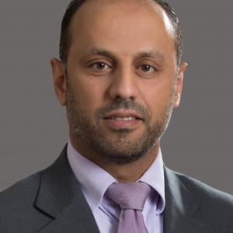
Personal
Photo

Dr. Mohammad Tawfiq Battah

Personal information
Title: Faculty member
Academic Rank: Assistant Professor
Date & Place of Birth: 15-3-1977
Nationality: jordanian
Address:Amman-dahiat alrasheed
Phone No.:00962-796083117
e-mail:m.batah@aau.edu.jo

Academic qualifications
Degree | Major | Duration  (From-To) | University | Country
Ph.D. In Law |  | 2012 | Institute of Arab Research& Studies | Egypt
M.Sc | In Law | 2003 | Institute of Arab Research& Studies | Egypt
B . Sc | In law | 1999 | , Jerash University

Teaching experience
Duration | Rank | Institution | Department/Faculty | Country
(2014/2021) | Assistant Professor | Amman Arab University | Department of Private Law | Amman

Other experience
Duration | Rank | Institution | Department/Faculty | Country

Publications
Journals
Dr. Mohammad Battah |  | Claim of Transport Commission Agent Liability and Compensation Provisions |  |  | Journal of Social Sciences (COES&RJ-JSS | Volume 9, Number 1, January 2020 | January  2020
Dr. Mohammad Liability Limits of Journal of Social Volume10, January
Battah Transport Commission Sciences , Number 1 2021
Agent (COES&RJ-JSS January 2021

Conferences
Author/s  (In Order) |  | Title |  | Conference |  | Country |  | Date

Books
Author/s  (In O Battah,mohammad rder) | agency commission for transport Title | Publis alwaraq her | Edition | D2014ate

Memberships OF Scientific and professional societies
university Committees

Workshops Attended
Workshops Offered

Research interests
Languages

Other Community activities
Awards received

Graduate Students Supervision
Student Name | Thesis Title
References

