Date 26/09/2021
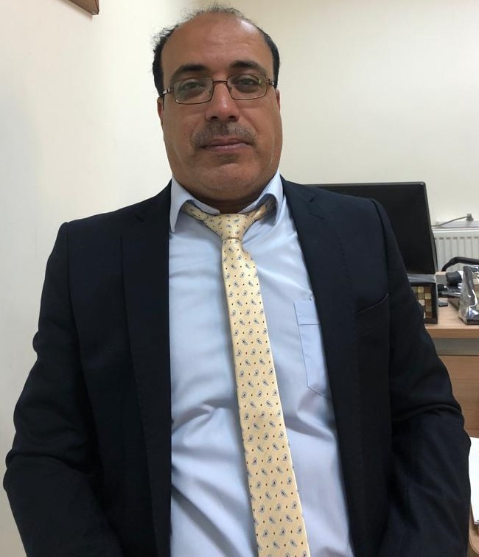
Personal
Photo

Salman mohammad salman aBU lEHYEH

Personal information
Title: Faculty member
Academic Rank: Assistant professor
Date & Place of Birth:5/1/1978
Nationality: Jordanian
Address: Jarash
Phone No.:0788068993
e-mail:salman-m-s@aau.edu.jo

Academic qualifications
Degree | Major | Duration  (From-To) | University | Country
Bachelor | Business Administration | 1995-1999 | Jarash University | Jordan
Master | Business Administration | 1999-2002 | Jouba University | Sudan
PhD | Business Administration-Marketing | 2007-2011 | Souz Canal University | Egypt

Teaching experience
Duration | Rank | Institution | Department/Faculty | Country
2 Year | Assistant professor | Majmua University | Business Administration | Saudi Arabia
6 Year | Assistant professor | Amman Arab University | Business Administration | Jordan

Other experience
Duration | Rank | Institution | Department/Faculty | Country
3 Years | Management and financial consultant | Aramco | Exploration Department | Saudi Arabia
2 Years | General Manger | Badyat Al Kher | - | Saudi Arabia
1 Year | Administration manager | Altameer Company |  | Saudi Arabia

 |  |  |  | Publication
 | Authors |  | Title | Journal | Issue |  |  | Year
 | Mohammed Mufaddy Al-Kasasbeh 1, Mohammad Izzat Alhalalmeh 2 & Salman Mohammad Abu Lehyeh |  | Business Incubators and its Effect on Success of Incubated Firms in Jordan | International Business management | 1 |  |  | 2017
 | Abulehyeh ,Salman Al- Zoubi, Ali |  | The Role of changing Management In The Process of Enhancing the Strategic Marketing Planning in Jordanian Industry sector (Model – Complement ) | International Management of Business and Management | 5 |  |  | 2017
 | Al- Zoubi, Ali , Abulehyeh ,Salman |  | The Role of Risk Management In Enhancing the process of Strategic Marketing Decision – Making : A Prospective Study of a sample of Jordanian Industrial Companies | International Management of Business and Management | 3 |  |  | 2017
Al- Zoubi, Ali , Abulehyeh ,Salman |  | The Role of Risk Management In Enhancing the process of Strategic Marketing Decision – Making : A Prospective Study of a sample of Jordanian Industrial Companies |  | International Management of Business and Management |  | 3 | 2017
Abulehyeh ,Salman , Alhosani Saed |  | The Impact of Management Information System on the Employees Performance Management |  | International Journal of Human Resource Studies |  | 3 | 2019
Malek Alharafsheh, Alaa Harahsheh, Salman Abu Lehyeh |  | The Impact Of Entrepreneurs Characteristics Of Private Jordanian Universities Leaders On Strategic Performance: The Mediating Role Of Strategic Planning |  | International Journal Of Scientific & Technology Research |  | 10 | 2021
Lehyeh, M Alharafsheh, E Ahmed, M Alzghoul, DA Alnawafleh |  | Knowledge Management and its Impact on the Organizational Learning: An Experimental Study |  | Ilkogretim Online |  | 20 | 2021
Salman Abu Lehyeh, Malek Alharafsheh, Mahmoud Alhhizzawi |  | Understanding the Impact of knowledge Management on Marketing in Jordan |  | PalArch Journal of Archaeology of Egypt/Egyptology |  | 18 | 2021
Salman Abu Lehyeh |  | corporate social responsibility leads to archive corporate social goals: theoretical and managerial discussion |  | Academy of entrepreneurship journal |  | 27 | 2021
Salman Abu Lehyeh et al |  | The Effects of Total Quality Management Practices on Strategic Performance Using the BSC Methodology: The Mediating Role of Knowledge Sharing |  | Academy of strategic management journal |  |  | 2021

Conference
Date | Country | Conference | Title | Author
2016 | Amman/Jordan | Faculty of Business | Human capital in organization era | Salman Abu Lehyeh
2018 | Amman/Jordan | Faculty of Business | Road Map Of Sustainable development | Salman Abu Lehyeh
2018 | Amman/Jordan | Faculty of Business | Road Map Of Sustainable development | Salman Abu Lehyeh
2018 | Amman/Jordan | Faculty of Business | Road Map Of Sustainable development | Salman Abu Lehyeh

Books
Author/s  (In Order) | Title | Publisher | Edition | Date

Memberships OF Scientific and professional societies
university Committees
1. quality committee
2. students disciplinary committee
3. students affairs committee
4. library committee
5. course equlevancy committee
6. Effectiveness committee

Workshops Attended
1. e-learning
2. Exams
3. Course file
4. Courses planning and Courses learning outcomes
5. Problems and issue of scientific research
Workshops Offered

Research interests
- Customer Relationship Management (CRM)
- Customer Satisfaction
- Organization Learning
- Marketing.
- Human Resource Management.

Languages
- Arabic
- English

Other Community activities
Awards received

Graduate Students Supervision
Student Name | Thesis Title
- Taher Al Raheafa
- Abed Al Slehat
- Esra Al Talhoni
- Ala Al Jarabaa
- Saed Al Hosani
- Asad Al Qlhati
- Leath Bani Hamdan
- Yazen Al Meharat

References
- Mohammad Al Kassasba 0777407226
- Aktim Al Sarira 0799046606

