Date 17/10/2021..
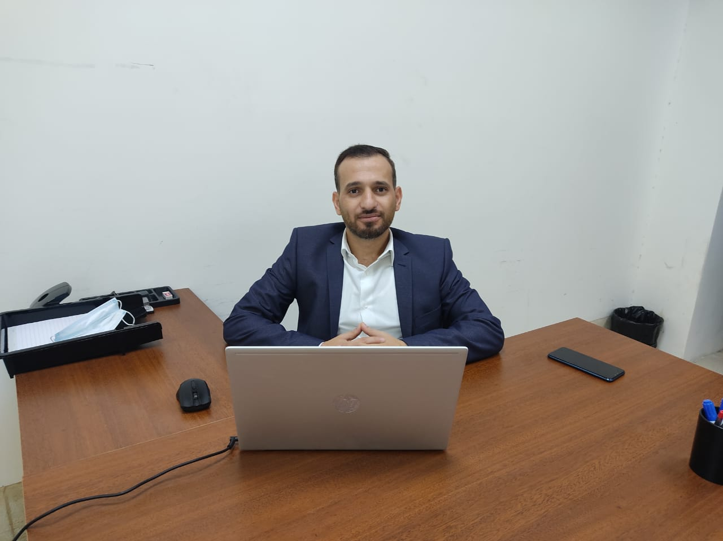
Personal
Photo

mohammad abdel qader marei bany baker

Personal information
Title: faculty member
Academic Rank: Assistant Professor
Date & Place of Birth:25/12/1984
Nationality:Jordanian
Address:Irbid
Phone No.:0792924741
e-mail:m.banibaker@aau.edu.jo

Academic qualifications
Degree | Major | Duration  (From-To) | University | Country
PhD | Computer information systems | 2012-2017 | National university of Malaysia | Malaysia
Master | Information Technology | 2010-2012 | University Utara Malaysia | Malaysia
BSc | Computer Science | 2002-2007 | Mutah University | Jordan

Teaching experience
Duration | Rank | Institution | Department/Faculty | Country
2018-2020 | Lecturer | Jadara university | Management information systems/ business | Jordan
20121 | Lecture | The world Islamic university | Computer science | Jordan

Other experience
Duration | Rank | Institution | Department/Faculty | Country

Publications
Journals
Author/s  (In Order) | Title |  | Journal | Vol./No. | Publication Date
Mohammad Bany Baker, Zawiyah M Yusof The effects of social capital and individual factors on knowledge sharing among ERP system users International Journal on Advanced Science, Engineering and Information Technology 6/6 2016
MOHAMMAD BANY BAKER, ZAWIYAH YOUSOF FACTORS INFLUENCING KNOWLEDGE SHARING IN ENTERPRISE RESOURCE PLANNING SYSTEM USAGE IN SMALL AND MEDIUM ENTERPRISES Journal of Theoretical & Applied Information Technology 95\8 2017
Mohammad Bany Baker, Zawiyah Mohammad Yusof A framework for knowledge sharing in ERP system usage in small and medium enterprises: a preliminary review International Journal of Business Information Systems 24\3 2017
Abdel Rahman ELDALABEEH, Mohannad Obeid AL-SHBAIL, Mohammad Zayed ALMUIET, Mohammad BANY BAKER, Dheifallah E’LEIMAT Cloud-Based Accounting Adoption in Jordanian Financial Sector The Journal of Asian Finance, Economics, and Business 8/2 2021
Mohammad Zayed Almuiet Maryam Mohamad Al-Zawahra, Mohammad Bany Baker Arabic Financial Stock Prediction Approach Based On Deep Learning Technique INTERNATIONAL JOURNAL OF SCIENTIFIC & TECHNOLOGY RESEARCH 9/2 2020

Conferences
Author/s  (In Order) | Title | Conference |  | Country |  | Date

Books
Author/s  (In Order) | Title | Publisher | Edition | Date

Memberships OF Scientific and professional societies
university Committees

Workshops Attended
Workshops Offered

Research interests
Artificial Intelligence, Information Systems, Technology Adoption, Data Mining

Languages
Arabic native
English excellent

Other Community activities
Awards received

Graduate Students Supervision
Student Name | Thesis Title
References

