Family name: AL-Shibly
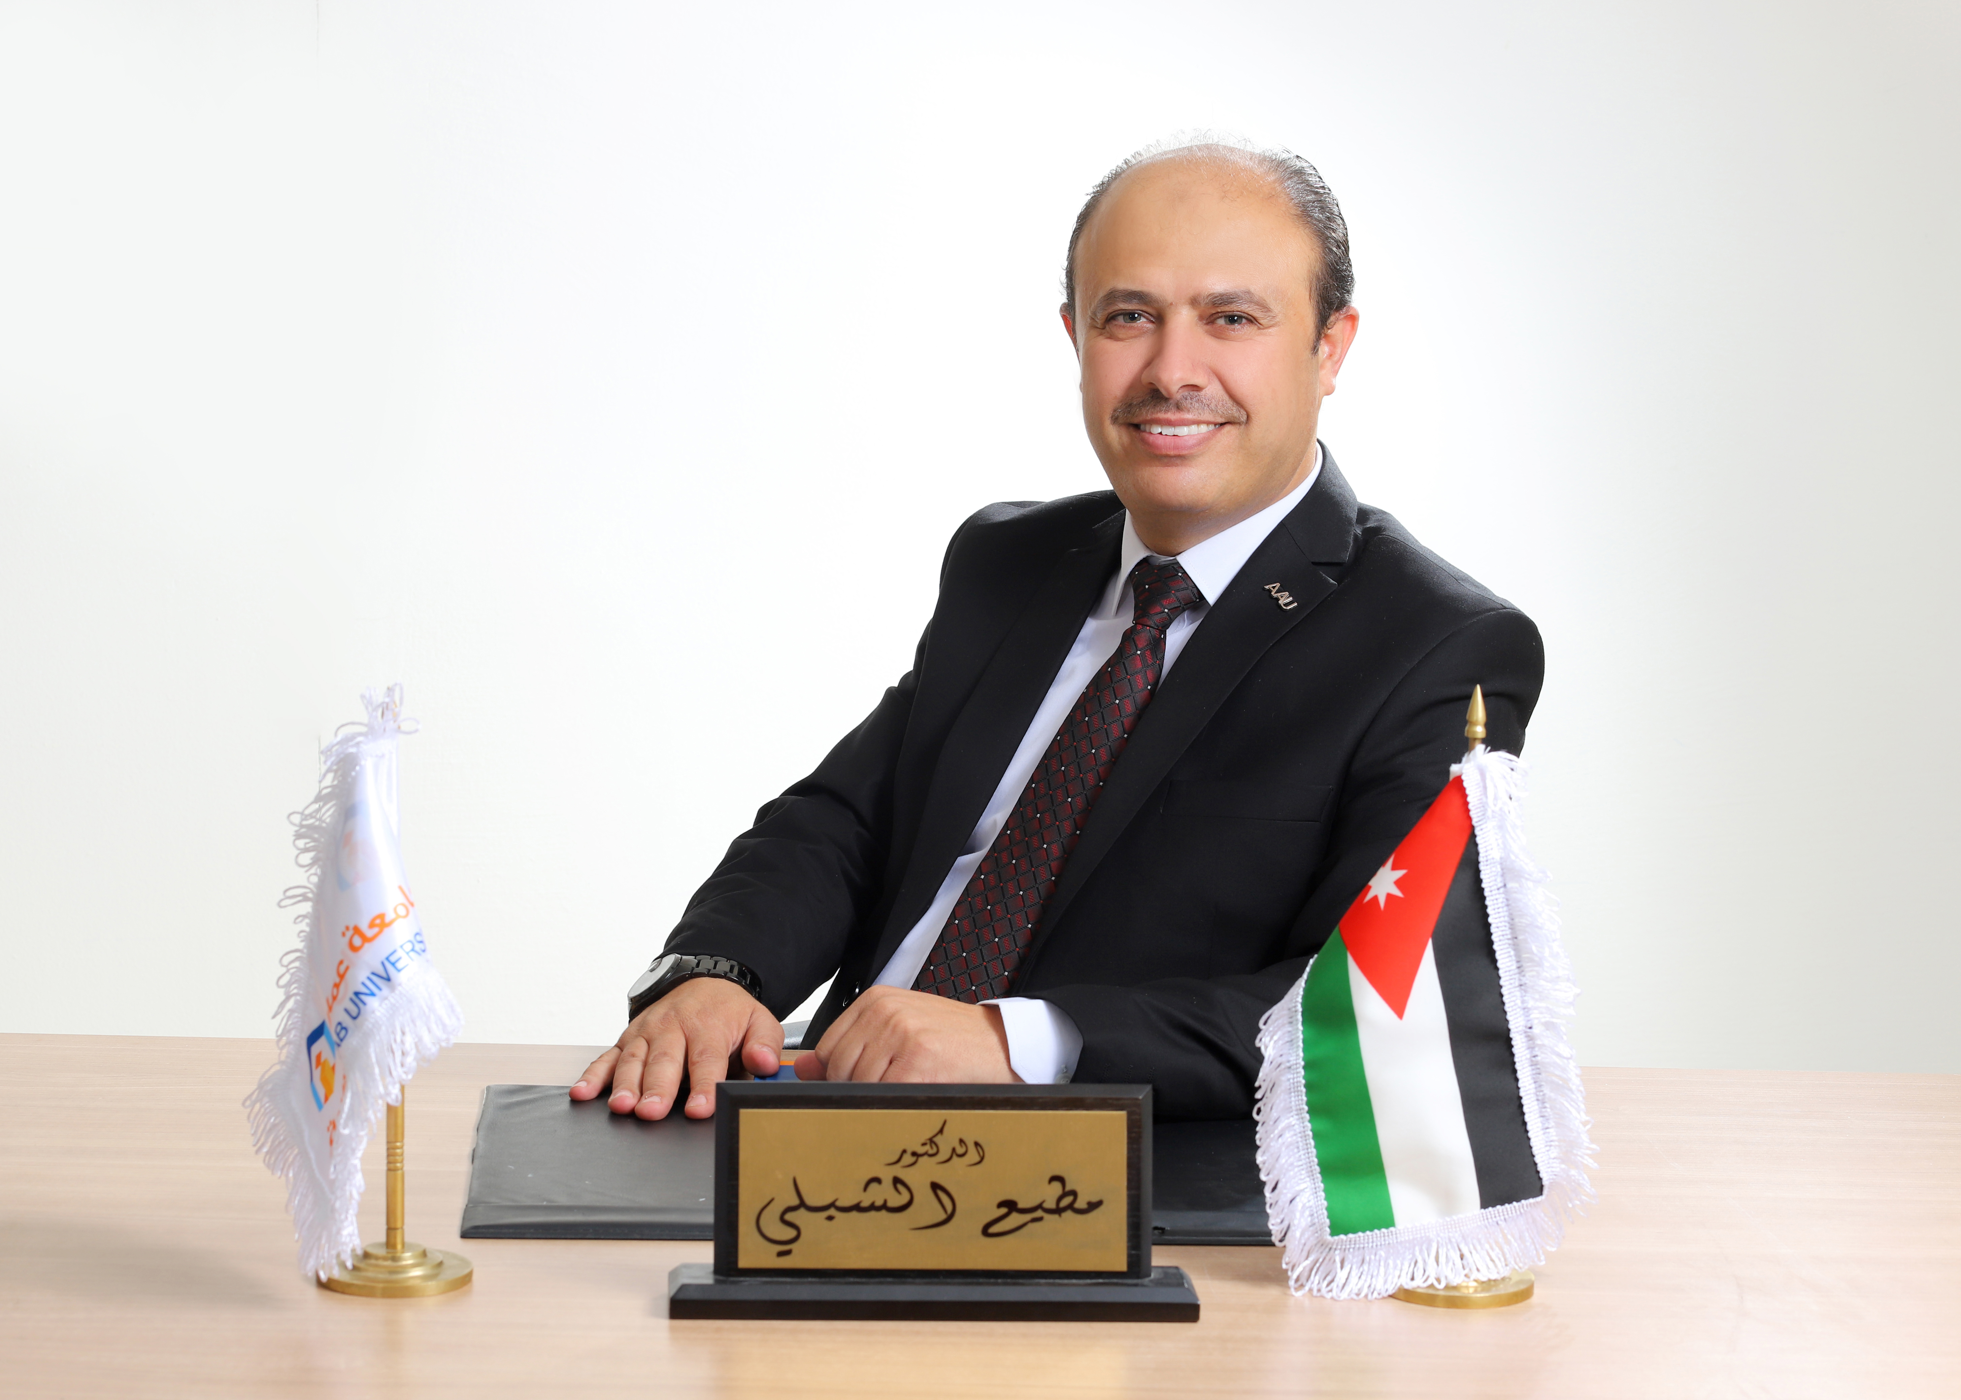
First names: Motteh
Date of birth: 20/01/1973
Nationality: Jordanian
Civil status: Married
Education: PHD

Dr. Al-Shibly’s Bio
Dr. Mottee S. Al-Shibly he is Associate Professor specialist Business Administration and Marketing, and he was a Head of Marketing Department and Management Information System Department, College of Business Administration, Amman Arab University and he was Director of Entrepreneurship and Community Initiatives Center at Amman Arab University, Expert on Food Processing and Marketing and supply chain ,Expert certified by( GO EEPORTING, Jordan chamber of industry and faculty for factory national program) in the audit of Jordanian export to the European union (study needs of European markets and estimation of sales volume, sales forecasting), developer of sales management platform with EDRAK, International certified trainer from international collage in London ( ICL), Certified trainer on communication skills (negotiation skills, persuasion skills , creativity under work pressure , time management, thinking outside the box ), expert in marketing and supply chain certified by agricultural engineers association, a consultant in the fields of Socio-Economic and harvest water management and tourism marketing at the many NGOs (ICARDA, European Union, Near East Foundation, trainer of trainers (TOT), certified instructor for many of the organizations on several areas (marketing, promotion, gender, project management, gender and woman empowerment), and work Directory of Monitoring and evaluation, Ministry of Agriculture As Ahead of Monitoring the execution of stockholders supporting actions (MESSA) section . Dr. Al-Shibly earned his PhD in Philosophy in Business Administration\ Marketing Specialization from The World Islamic Sciences and Education University (WISE) Thesis: “Factors Affecting Social Media Network Adoption and Purchase Intention as a Marketing Tool”, Jordan. In addition, Dr. Al-Shibly earned his Master’s degree, MBA, \ Marketing Specialization from The Arab Academy for Banking and Financial Sciences and earned his BSc. from University of Jordan in the fields of Agricultural Business Management. He launched the initiative to prepare for green, which aims to educate the community to preserve the environment, raise awareness of green products and green manufacturing, and a certified trainer on green marketing.

- Experience in the development of local communities, with a particular focus on small and medium enterprises issues.
- Experienced in donor and funded programs, including seven years with (ICARDA) and fife years with (CARE) and one year in (IFAD) projects.
- Professional in Participatory Rapid Appraisal (PRA), for more than sixteen years.
- Professional in Monitoring and Evaluation Projects for more than ten years.
- Implemented several generations - income projects.
o Contribute to the creation of many cooperative societies to serve local communities in northern, eastern and southern Jordan Contributed to develop a guide of financial institutes and lending organizations
o Knowledge of the World Bank and the UN neighborhood policy
o Ability to analyze the Jordanian socio-economic, extract trends and recommend actions
o Professional drafting of project proposals writing based on strategic planning models.
o Having the ability to interact effectively with local community and privet sector as well as public institutions
o Assisted to establish the concept of gender.
o Good understanding of local communities and marketing sector, specifically in enhancing productivity, initiating small and micro projects to increase revenues and create jobs.
o Ability to build bridges between private and public sectors (Public Private Dialog)
o Good communication, interpersonal, presentation and reporting skills. Designing and implementing media campaigns.
o Moderation: facilitated many workshops, focus group, festivals and conferences.
o Certified trainer by : (CARDNE) and (JICA) .
o The ability to deal with the communities and the collection data.

Dr. Al Shibly's Vision:
Developing entrepreneurship among young people, to create a pioneering generation capable of creativity, and marketing itself and improving socio-economic.
Qualifications and Education:
Institution | Degree(s):
The World Islamic Sciences and Education University (WISE) 2010-2014 | The Degree of Doctor of Philosophy in Business Administration. Thesis: “Factors Affecting Social Media Network Adoption and Purchase Intention as a Marketing Tool”  .
The Arab Academy for Banking and Financial Sciences.2005 | Master of Business Administration / Marketing Specialization
The Arab Academy for Banking and Financial Sciences.2004 | High Diploma of Business Administration / Marketing Specialization
University of Jordan 1991-1995 | Agricultural Business Management

Consulting and Training Specialisations and Experiences:
Communications Skills, Social Media Marketing, Marketing of agricultural products
Digital Marketing, Marketing Strategy, Communications Skills, Marketing A to Marketing Management, T0T, Empowerment of Rural Women in Small Agricultural Project Loan Management, The concept of gender, marketing of agricultural products, Social Media Marketing, Knowledge Management and Social Media, Marketing of agricultural products, Advanced Agricultural Marketing, Communications Skills.
Consulting Experiences:
- Expert certified by (GO Exporting, Jordan chamber of industry and faculty for factory national program) in the audit of Jordanian export to the European union (study needs of European markets and estimation of sales volume, sales forecasting) 2019- present.
- Developer of sales management platform with EDRAK,2019- present.
- Expert in marketing certified by agricultural engineer’s association, 2017-present.
- Researcher in strategic planning for tourism marketing, the European Union.
- Developer Projects of TEMPUS Programme, Grenoble Ecole de Management, Grenoble, France (2009-2013). These projects were designed to transfer knowledge in the educational - make enseignement of Management European academic institutions towards academic institutions beyond the Southern Mediterranean.
- Desertification Project Water Harvesting activity, range land, socio economic, JORDAN/ ICARDA Project, 1998-2003.

Specific experience:
Country | Date from – Date to | Position
Jordan | 28/09/2020 – Present | Associate Professor, Business dministration, College of Business Administration, Amman Arab University.
Jordan | 17/10/2015 – 27/10/2020 | Assistant Professor, Marketing Department, College of Business Administration, Amman Arab University.
Jordan | 01/09/2017-01/09/2020 | Director of Entrepreneurship and Community Initiatives Center and incubator business at Amman Arab University.
Jordan | 01/09/2018-01/09/2019 | A Head of Marketing Department and Management Information System Department, College of Business Administration, Amman Arab University.
Jordan | 12/2/2015 – Present | Part time Assistant Professor, Marketing Department, Princess Sumaya University for Technology.
Jordan | 1/2/2015 - Present | Researcher in strategic planning for tourism marketing, the European Union
Jordan | 1996 - Present | Field studies and communication with communities, government sector and private sector
Jordan | Short Visits | Marketing Research Technical Assistance Training and Monitoring Consultancy
Jordan- France | 2009-20013 | Developer Projects of TEMPUS Programme, Grenoble Ecole de Management, Grenoble, France (2009-2013). These projects were designed to transfer knowledge in the educational - make enseignement of Management European academic institutions towards academic institutions beyond the Southern Mediterranean.
Jordan | 2008-2010 | Instructor, Department of Business Administration, College of Business Administration and Economics - AL Hussein Bin Talal University /Jordan.

Professional Experience:

Location | Company | Function
Jordan | Food Security Unit | Marketing Researcher and Socio-Economic specialist and trainer
Jordan | scientific Research Support Fund (SRFS) | Head of the Department of Agricultural Sciences and Medical
Jordan | Agricultural Risk Management fund ( ARMf) | Technical Director
Jordan | Food security project  Implemented by UNDP and MOA | Head of Studies and Strategic Planning (SSP )
Jordan | Directory of Monitoring and evaluation, Ministry of Agriculture | Ahead of Monitoring the execution of stockholders supporting actions (MESSA) section
Jordan | Department of Business Administration, College of Business Administration and Economics - AL Hussein Bin Talal University /Jordan. | Instructor
Jordan | Ministry of Agriculture | Monitoring and Evaluation and Environmental Public  Awareness Specialist
Jordan | International Fund for Agricultural Development (IFAD) | Socio – Economist
Jordan | ICARDA  And MOA | Socio-economist / GIS Technician, Desertification Project
Jordan | Al- Adjure Farms. | Marketing Manager

Committees and government posts

Location | Date from – Date to | Committees and government posts
Prime Minister | 2010-2011 | Ahead of the Technical Committee of the national agenda  data update project update and modify the national agenda
Ministry of Environment | 2010-2011 | Coordinator - to develop the center of the environment
Ministry of Planning | 2010-2011 | Coordinator - Developer of the program of development of the governorates of Jordan
Ministry of Industry and Trade | 2010-2011 | Focal point - the center of investment

Other Experience & Achievements:

- Participated at a training course on SERMANTEQ – Workshop for Mediterranean Trainers , GRENOBLE – FRANCE JOLY 2009 .
- Participated at a training course Leadership skills and change management - National Institute for Training, in Jordan (June 2011).
- Participated at Training course entitled "National Information System (in order to strengthen the capacity of the Ministry of Agriculture to establish a bank for agricultural information by (FAO) AND MOA in Jordan (June 2010).
- Participated at Training course on" data statistic analysis" SPSS programme in Jordan university.(June- August 2007).
- Participated at Training course on Trainer Training by ICARDA, IN Jordan and Syria (June 2004-January 2005).
- Cost Benefit Analysis Capacity Building Workshop by organized for the initiative for Dryland management multilateral working group on the environment and the University Reading /UK ( December 2004 ).
- pilot programme on “ logical framework in context of project cycle management “ by IFAD, capacity building international/In WENT, and the national institute for training (NIT) at NEMTA national training unit in NIT / AMMAN (November 2004).
- workshop on communication skills, by Ministry of Agriculture and CARE in jordan (December 2003).
- Participated at Training course on Geographical Information and Remote Sensing - Syria (September 2001).
- Facilitated several workshops, brainstorming sessions ,focus group and seminars.

Published Research Papers in Refereed Conferences:
- Motteh Al-Shibly, Bushra K.Mahadin (2018), the influence of eWOM on Facebook on the Jordanian Consumers\' Intentions towards Restaurants, International Journal of Applied Business and Economic Research, Vol.16 (2018). (Accepted). (Index in Scopus)
- Motteh S Al-shibly, Salim Faysal AL-Nabulsi (2017), The Impact of Applying Marketing Service Ethics on Client’s Behavior: Applied Study on Jordanian Banks, international Journal of Business and Social Science, 8(10), 163-177. (Index in orlich)
- MOTTEH S. ALSHIBLY AHMAD SALIHALNASER, JORDANIAN PUBLIC UNIVERSITY QUALITY MEASUREMENT: USING STRUCTURAL EQUATION MODEL, the IIER International Conference, Paris, France, 13th-14th November 2017, 29-36. (Index in Scopus)
- Motteh Saleh Al- Shibly, Khaldon hamdan Alkhawaldeh (2017), The Impact of Marketing by Relationships To Achieve Competitive Advantage A Case Study "Cellular Telecommunication Companies in Jordan", Journal of Marketing Management, 15(2), 1-11. (Index in orlich)
- Al-naser Ahmad, Al-Shibly Motteh, 2017, Effect of applying e-marketing mix elements on customer satisfaction in the telecommunications sector: case study of an Umniah company, Journal of Advanced Social Research, 6(11): 11-39, 2016, ISSN: 2231-8275.
- Al-Shibly Motteh, Al-naser Ahmad, 2017, The Effect of Marketing Strategy on Customer Loyalty: Conceptual Research, Journal of Islamic and Human Advanced Research, 7(3):33-47, 2017, ISSN: 2231-8968.
- Al-Shibly Motteh, Reem M. Alrefai’,2016,The Effect of Microfinance on Jordanian Women’s Socioeconomic Empowerment and Marketing Practices, STRATEGICA: Opportunities & Risks in the Contemporary Business Environment, fourth edition ,Bucharest ,Romania, October 20-21,2016 ,pp 296-307.
- Al-Shibly Motteh, Alhawari Samer and Haroun Alryalat, 2014, Attitudes toward using Social Media Networks (SMN) in Marketing as New Tools,International Business Information Management Association (IBIMA) Conference on Creating Global Competitive Economies: 2020 Vision Planning & Implementation, Rome, Italy, (2013) ISBN: 978-0-9860419-1-4. Indexed by (Thomson , ISI),pp.574-589.
- Abu-ELSamen, Amjad., Akroush, Mamoun., AL-Khawaldeh, Fayez. and AL-Shibly, Motteh. (2011), Towards An Integrated Model of Customer Service Skills and Customer Loyalty: The Mediating Role of Customer Satisfaction, International Journal of Commerce and Management, Vol. 21, No. 4, pp. 349-3.
- Akroush, Mamoun., Abu-ELSamen, Amjad., AL-Shibly, Motteh. and AL-Khawaldeh, Fayez. (2010), Conceptualization and Development of Customer Service Skills Scale: An Investigation of Jordanian Customers, International Journal of Mobile Communications, Vol. 8, No. 6, pp. 625-653.

Super adviser:

- The Impact of Digital Marketing via Smartphones on Consumers' E-Purchase Satisfaction: A Case Study on Students of Al-Yarmouk and Amman Arab Universities
- THE IMPACT OF DIGITAL MARKETING MEANS ON ACHIEVING THE OBJECTIVES OF JORDANIAN HEALTH CHARITIES.
- The Impact of Pink Marketing on the Competitive Advantage of Jordanian Tourist Restaurants.
- The Impact of Organizational Learning in Jordanian Commercial Banks Performance.
- THE IMPACT OF KNOWLEDGE MANAGEMENT PROCESSES ON PERFORMANCE IN THE JORDANIAN TELECOMMUNICATIONS COMPANIES.
- THE IMPACT OF PROMOTION MIX ON THE FINANCIAL INCLUSION IN JORDANIAN ISLAMIC BANKS.

