Date 22-09-2021
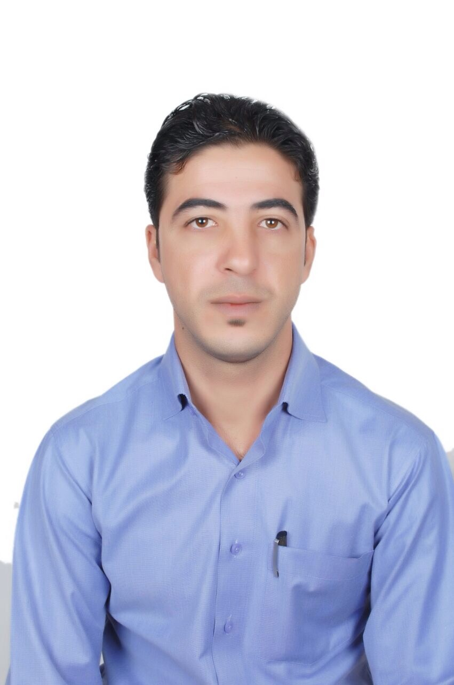
Personal
Photo

Dr. nahed habis alrawashedh

Personal information
Title: Faculty member
Academic Rank: Assistant professor
Date & Place of Birth: 25- January
Nationality: Jordanian
Address: Amman – Jordan
Phone No.: 0792082053
e-mail: nahed.habis@aau.edu.jo

Academic qualifications
Degree | Major | Duration  (From-To) | University | Country
Bachelor | Accounting | 2005-2009 | Mutah | Jordan
Master | Financial Accounting | 2010-2012 | Mysore of University | India
Ph.D. | International Standards Accounting | 2013-2015 | Aligarh Muslim University | India

Teaching experience
Duration | Rank | Institution | Department/Faculty | Country
2016- Till now | Assistant professor | Amman Arab University | Accounting | Jordan

Other experience
Duration | Rank | Institution | Department/Faculty | Country
2005 – 2009 | Accountant | Greater Karak Municipality | Finance Dep | Jourdan

Publications
Journals
Author/s  (In Order) | Title |  | Journal | Vol./No. | Publication Date
Asiya Chaudhary,  Nahed Habis Alrawashdeh | Unethical Practice in International Marketing. | international journal of engineering and technical research | 2 | 2014
Nahed Habis Alrawashedh | The role of creative and fiscal accounting in the process of enunciating accounting and fiscal information. | Interciencia Journal | 3 | 2018
Nahed Habis Alrawashdeh | The Role of Forensic Accounting in the face of Accounting Fraud practices and their Impact on the Financial Statements. | Ciencia e Tecnica Vitivinicola Journal |  | 2018
Mazen Al- omari Shereen Al ali , Haitham Alali, Nimer Alslihat, Nahed Alrawashedh | The impact of financial information systems on the quality of financial statements : The case of Jordanian commercial banks | International Journal of Applied Business and Economic Research | 152017 | 2017
NAHED HABIS ALRAWASHDEH, MARAL EJMALIAN | International Accounting Standards and the Global Financial Crisis | International Journal of Modern Communication Technologies & Research (IJMCTR | 2 | 2014
Mazen Al- omari Shereen Al ali , Haitham Alali, Nimer Alslihat, Nahed Alrawashedh | Accounting disclosure in the light of international accounting standards | international journal of economic research |  | 2017
Alaa Said Alkhatib  Nahed Habis Alrawashdeh  Nimer Alslihat  Malek Alharafsheh  Ahmad Alnaser | The role of Islamic accounting in the development of Islamic banks | International Journal of Business and Management | Accepted | 2019
Nahed Habis Alrawashedh Nimer Alslihat | The role of accounting system in the internal control | international journal of scince and research | 5 | 2016
Nahed Habis Alrawashedh Ahmad Salih Mheidi Alnaser, Mustafa H AlShamaileh, Mohammed Abdulellah Yousuf Saeed | Adoption of E-Commerce by SMEs and Its Impact on Customer Satisfaction | Journal of Advanced Social Research | 8 | 2018

Google Scholar Link : https://scholar.google.com/citations?user=iyQom2oAAAAJ&hl=en&authuser=2

Conferences
Author/s  (In Order) | Title | Conference |  | Country |  | Date
المؤلفون  (بالترتيب) | العنوان | المؤتمر
معتز الزعبي  ناهض الرواشدة | اثر تطبيق قواعد الحاكمية المؤسسية على مخاطر التشغيلية في البنوك التجارية الأردنية | راس المال البشري في عصر المعرفة
مازن العمري  زياد السعيدات  ناهض الرواشده  معتز الزعبي | راسنظم نظام التكاليف المبنية على الانشطة(ABC) وتحسين قرار التسعير دراسة على الشركات الصناعية المدرجة في بورصة عمان. |  | الريادة والإبداع في المشاريع الصغيرة

Books
Author/s  (In Order) | Title | Publisher | Edition | Date

Memberships OF Scientific and professional societies
university Committees
1- Member of the Quality Assurance Committee for the academic year 2018-2019.
2- Member of the website committee.
3- Member of the Examinations Committee.
4- Member of Erasmus Plus Committee.
5- Member of E-Learning Committee.

Workshops Attended
1- E-learning course and re-electronic courses
2- Achievement tests course and its applications
3- Course preparation course
4- Preparing course plans and linking them to the education and program outputs

Workshops Offered

Research interests
Auditing - International Accounting Standards - Creative Accounting.

Languages
Arabic + English

Other Community activities
Presenting a lecture at Salt Islamic School entitled Vocational Education.

Awards received
Graduate Students Supervision
Student Name | Thesis Title
Emadaldeen Mahana Khadeem “The impact of internal audit in reducing the risk of money laundering operations in Iraqi commercial banks”
Saif Samy Abas . “ The impact of oil revenues and mineral wealth on the level of investment in the public budget of Iraq”

References
Dr. Asiya Chaudhary | Professor | asiya.chaudhary1@gmail.com  00919837008778
Dr. Basavanayaka Nagaraju | Professor | 009198452 59913  0091821 241 9837
Dr. Mohammad Al-Dahiyat | Professor | maldahiyat@bu.edu.sa

